TMS USERS:
Reference: TMS Back Office Ticket Managers User Manual 1.0 Final 01 October 2019
We’ve noticed some inconsistencies with user management and wanted to provide a few user tips for your convenience. You can also find this info in the TMS Back Office Manager’s User Manual. Copy attached for your convenience. It is also located in TMS on the Support & Documentation page.

- Ensure you have an up-to-date Office Update on file with MTP that contains a current list of users.
- When a user from your location terminates, remove their account. (You may do this by going to that employee’s role and choosing the garbage can icon to the far right)
- DO NOT toggle on the manager toggle for any user under their roles (only MTP should be using the manager toggle)
- DO NOT use the Task or Invite links located on the left-hand side of the Application Access page.
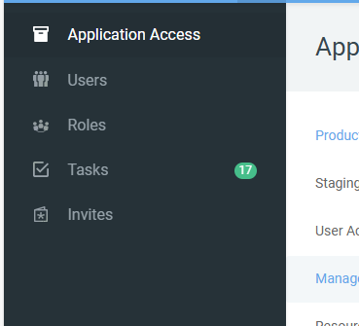
- Managers, make sure you are logging in routinely, so your access does not get locked.
- It is the Manager’s responsibility to manager their location users (Ticket admins should not be managing users)
  - Ensure your users log into the system and are fully trained
  - Ensure accounts are locked/unlocked as needed or deleted when an employee terminates.
- Users who have not logged in for more than 30 days will have their access locked.
- Users who have not logged in for more than 90 days will be completely removed.

