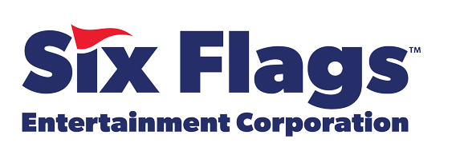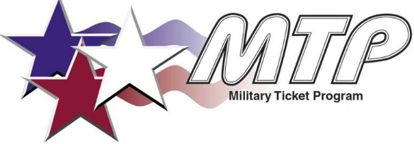
California
- Knott's Berry Farm | Buena Park, CA
- Knott's Berry Farm Soak City | Buena Park, CA
- Six Flags Magic Mountain | Valencia, CA
- Hurricane Harbor | Valencia, CA
- Six Flags Discovery Kingdom | Vallejo, CA
- Six Flags Hurricane Harbor Concord | Concord, CA
Georgia
- Six Flags Over Georgia & Hurricane Harbor | Austell, GA
Illinois
- Six Flags Great America & Hurricane Harbor | Gurnee, IL
- Six Flags Hurricane Harbor Rockford | Cherry Valley, IL
- Six Flags White Water | Marietta, GA
Maryland
- Six Flags America & Hurricane Harbor | Bowie, MD
Massachusetts
- Six Flags New England & Hurricane Harbor | Agawam, MA
Missouri
- Six Flags St. Louis & Hurricane Harbor | Eureka, MO
- Worlds of Fun / Oceans of Fun | Kansas City, MO

New Jersey
- Six Flags Great Adventure | Jackson, NJ
- Hurricane Harbor New Jersey | Jackson, NJ
New York
- Six Flags Great Escape Resort & Hurricane Harbor | Queensbury, NY
North Carolina
- Carowinds | Charlotte, NC/SC
Ohio
- Kings Island & Soak City | Mason, OH
Texas
- Six Flags Over Texas | Arlington, TX
- Hurricane Harbor | Arlington, TX
- Six Flags Hurricane Harbor Splashtown | Spring, TX
- Schlitterbahn Waterpark | Galveston, TX
- Schlitterbahn Resort | New Braunfels, TX
- Six Flags Fiesta Texas & Hurricane Harbor | San Antonio, TX

Virginia
- Kings Dominion & Soak City | Doswell, VA

