We are frequently asked for advice on how to create a price sheet &/OR how to reach out to vendors for collateral material.
To find price info:
- Go to Reports on the TMS drop down menu in back office
- Then choose Ticket Detail
You can pull this report by choosing any vendor or specifically choose a popular seller for your area or you can choose by state.
In the below example, I have pulled the report for attractions in the state of Georgia:

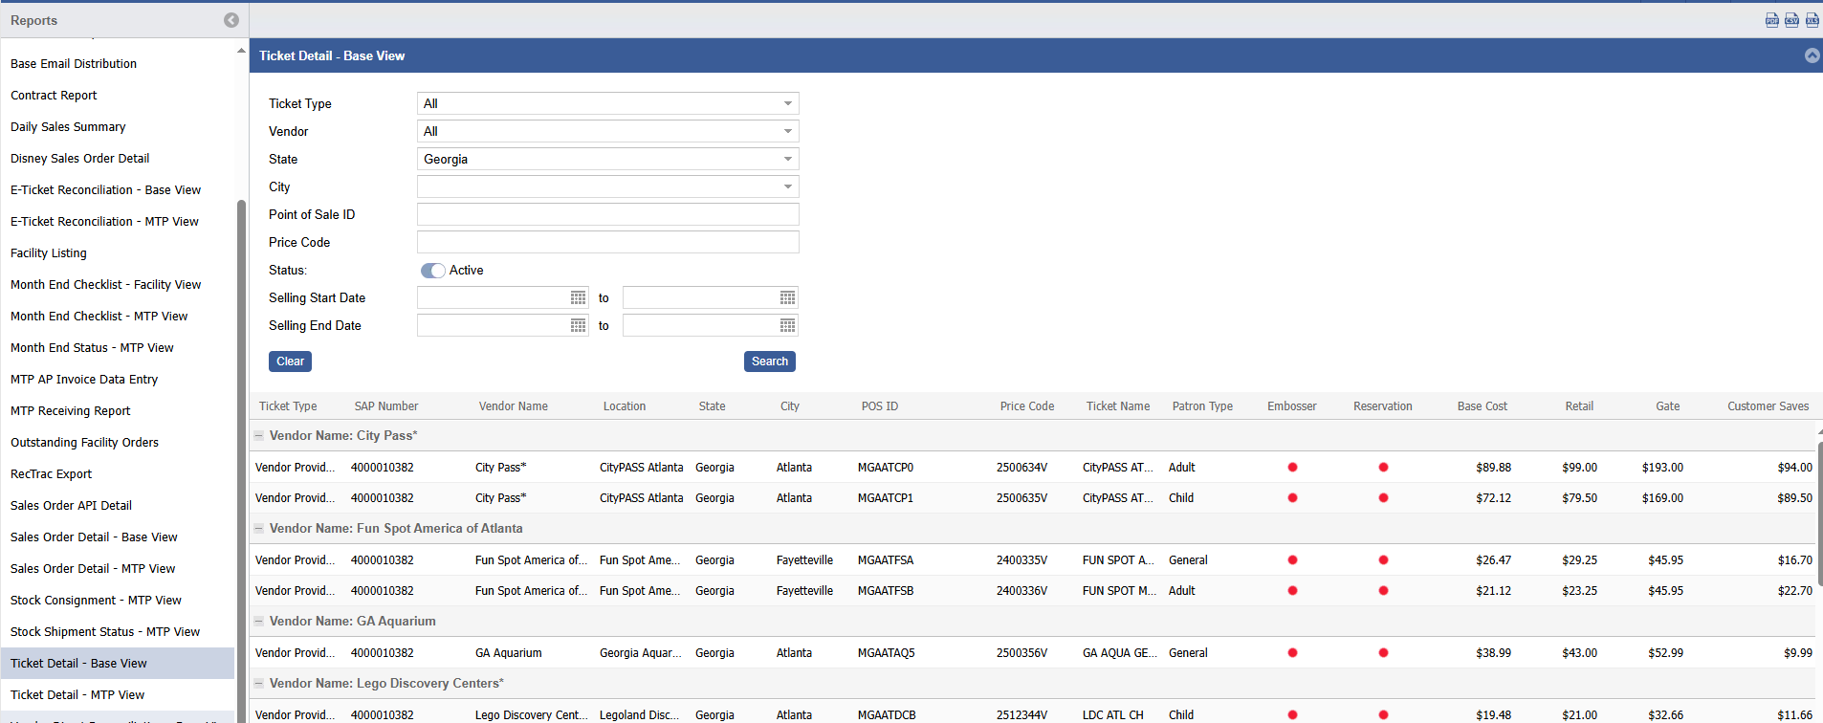

On the top right hand side of the screen you will see the icon that you click on to export this data to excel: (Note all TMS Reports are exportable to Excel)
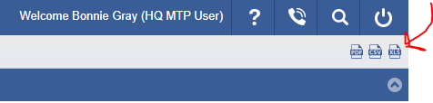

If using NMCI, you will need to click download original to get the output in the Excel format. Example below:

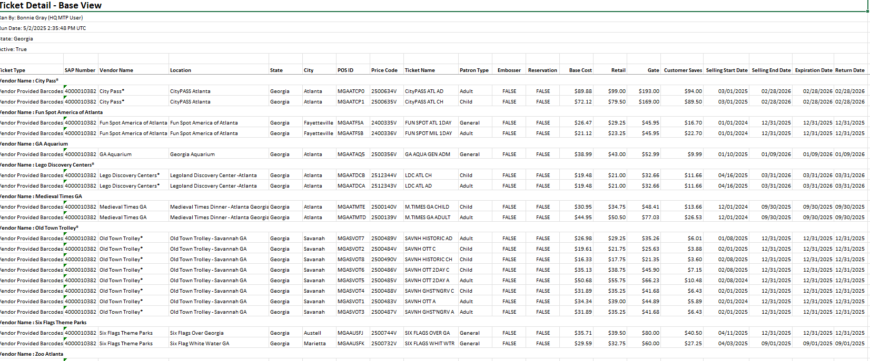

- If your Marketing Dept. creates price sheets for you, I recommend hiding or deleteing columns of info that they may not understand or that don’t need to be used on the price sheet. Columns such as Ticket Type; SAP Number; Embosser; POS ID; Price Code Base Cost; Reservation etc.
- Once you have a document that you feel they can work with, you will then want to refer to the Marketing POC spreadsheet located in TMS on the Support & Documentation page.
- In TMS on the right hand side, click on the question mark & choose Support & Documentation from the drop down.
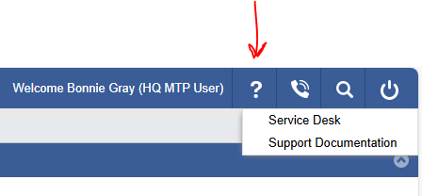
- Scroll down until you see Vendor_Marketing_Contacts_Links_Updated 2.28.25. This document lists the Marketing points of contact, email & phone numbers for each attraction. Reach out to them for logos for your price sheet, &/or collaterial material for your office such as posters, maps, etc. Ask about editable flyers so you can add your office name and phone number to the document. You would also want to reach out to these contacts when you plan a travel fair.
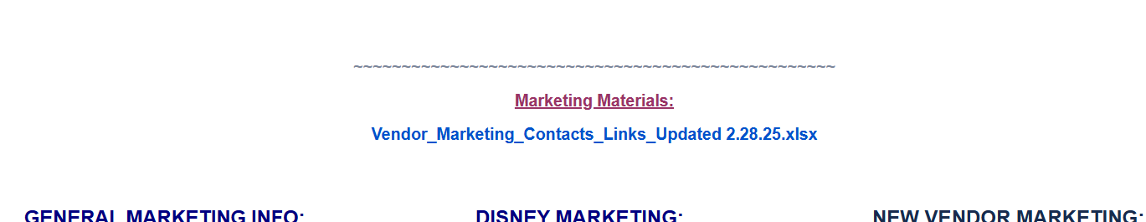

Got questions? Give us a call.
info_mtp.fct@navy.mil. 901-874-6891

