TRAVEL FAIRS
PURPOSE: The Ticket & Travel activity offers a vendor fair/show to allow customers to mingle with Ticket & Travel partners (hotels, theme parks, car rentals, cruise lines, etc.) to generate interest and future sales.

- Check your proposed date for the next year’s event with MTP to ensure there are not any conflicts with other installation travel fairs. Conflict in dates will potentially decrease the number of vendors who are available to attend your event. MTP will include your final date and event info when sent to vendor list.
- Pull the AR Statistics Report from TMS for the FY to determine your top 20 sellers. Add a filter & run a pivot table to find this info. Reach out to MTP if you need help with this step.
- Consider; is the Ticket Office large enough to host the event? If not, establish a plan for best location, estimated patron attendance, how many vendor booths will fit space, how many booths with electricity, building access and base access for vendors, budget.
- What to include in budget: Income booth fee; expenses light refreshments during fair to entice attendees; breakfast for vendor set up.
- Develop a registration form, invitation, etc.
- Send the registration form and invite to MTP to share with vendor list.
- Sponsorship – bags, prizes, etc.
- Marketing plan to invite base commands to visit the fair.
- How many staff members are needed to assist with the fair event? Will the ticket office require more staffing as well?
- Are price sheets and ticket office brochure up to date? Do you have enough price sheets/brochures to stuff in bags to give to each patron?
- Keep track of attendance.
- After Action Report – Vendor survey to ask what they liked or what could be improved upon for next event.
- If there is a nearby installation ticket & travel office, reach out to them to partner on your date to better utilize the vendor’s time.

The following is an outline that may be used to assist in planning a travel fair. The fair
should be as flamboyant as possible, and should always be in conjunction with another
promotion, such as sale at the Navy Exchange, fashion show at the club, Oktoberfest, car
show or Retiree Days. Remember, this is a marketing event with the purpose to SELL travel
and increase your revenue.
Travel Fairs are not for everyone. Remember, in order to entice a vendor to come there has to
be a win-win situation. This means they will be able to touch a lot of people. This is not a
recommended activity for smaller installations, although you may be able to do a joint
function with another event to draw a crowd or work a circuit to allow better return on
Investment (ROI) for the vendor.
This function should be jointly planned by the Contracted Leisure Travel Services (CLTS),
and ITT on your installation if you have a CLTS. The Contracting Officer's Technical
Representative (COTR) or Local Contract Monitor (LCM), should act only as coordinator
between the CLTS and MWR.

NOTE: Plan your travel fair as far in advance as possible and contact the
Military Ticket Program to be placed on the Travel Show Schedule.

TRAVEL FAIR CHECKLIST

SIX MONTHS OUT
- Hold a planning meeting. The principles attendees of this meeting should be a representative of the CLTS and the COTR, and the ITT Manager. Also, if a tentative location has been previously discussed, the facility manager for that location could be included.

- At this initial meeting there are several items that should be discussed and decided.

LOCATION
- The location of your travel fair is probably the most important decision that will be made. Usually, an ideal location is the Navy Exchange or Club. When deciding on a location, take into consideration the following:
• Traffic flow, both on foot and in auto.
• Sufficient display space.
• Ample parking.
• Vendor Space Availability

NOTE: If no covered area is available, consider using a large tent(s) or
have a rain plan.

DATE/TIME
- The date should be as close as possible to a payday. If not a payday, consult with the manager of the facility where the travel fair is being held to determine the high traffic days and times. Always plan an alternate date.

TYPE OF VENDORS
- Diversity produces the best show. Be sure to include:
• Tourist bureaus (both domestic and international)
• Tour operators
• Theme parks
• Vendors (ticket)

VENDOR RECEPTION
- This reception should be planned the night prior to the show or the middle of a circuit. This allows the MWR representatives, vendors, and the CLTS to network. It also allows time for the MWR to answer many questions, such as access to the base, parking, location diagram, accessibility of carts to transfer brochures, etc. A vendor packet with the answers to many of these questions could be handed out. It is suggested that this reception include food and beverages. Alcohol may also be available, but this should be set up on a "cash bar" basis. If there are club facilities on the base, this reception could be held here. This would be a good introduction to a MWR facility.

VENDOR LODGING
- The MWR and CLTS should negotiate with local hoteliers and obtain the best rate possible for the vendors. The hotel should be as close to the base as possible.

PRIZES
- Give vendors the opportunity to sponsor a prize.
- Recognize vendors for their contribution in promotional material.
- Create a prominent display the day of the show to recognize both the sponsoring vendors and recipients.

ENTERTAINMENT
- Entertainment is always good especially during slow patronage times. Cost of the entertainment is a consideration. Vendors could also sponsor the cost of the entertainment.

ESTIMATED EXPENSES
- Areas of expenses that should be considered are:
• Labor, use of MWR staff to set up and tear down the tables/booths.
• Tables and chairs, if not available through MWR.
• Vendor reception.
• Promotions.
• Any miscellaneous items (i.e. tent, electricity, etc.).
• Correspondence, Phone Calls, faxes and emails
FEE
- Based on the estimated expenses, determine the participation cost to the vendor. Charge only what is necessary to cover the cost of the travel fair. This is a "goodwill promotion" not a money maker.
- Confirm the date, location and time with the MWR Director, make sure that there are no major promotional conflicts.
- Meet with the manager of the facility where the travel fair will be held. Confirm the date in writing. Solicit ideas on joint promotions (i.e., NEX could promote resort wear, sale on travel items, spring or fall sales are also good as a tie-on). The Catering/Club operation may be able to promote catering or weddings.
- Contact other installations that you know have held successful travel fairs. Solicit ideas, advice and general tips. Create a network.

FIVE MONTHS OUT
- Arrange for entertainment, if desired.
- Negotiate hotel rates.
- Write a letter of invitation and design a registration form. Vendors should be encouraged to bring an interactive display that will attract attention (i.e., simple game with small promotional prize, be in costume, give away balloons, Frisbees with contest at specified times, etc.). The vendors should be reminded that this travel fair is geared to the traveler, not travel industry professionals. The letter should also mention sponsorship of door prizes. A response deadline should be set no later than 4 weeks after mail-out.

FOUR MONTHS OUT
- Compile a list of possible vendors. This list should include the vendor’s name, category, address and contact person. Determine the number of vendors in each category needed to make an interesting show. To create more patron interest for the travel fair, include a variety of vendors. It is suggested that you invite 30-50% more vendors than you need. Always retain your vendor list for
- future use.
- Make any suggested changes to the letter of invitation and registration form.
- Determine fee, include hotel and reception information. Mail letter to vendors.
- Design invitation for VIPs and compile VIP list.
- Hold a planning meeting. This meeting may include the COTR, the CLTO manager representative, the MWR and NEX facilities manager, a public works representative, the ITT manager, the MWR special events manager, the MWR marketing specialist, the MWR Director and any other POC involved with preparations.
- At this meeting there are several items that should be discussed and decided.

LETTER OF INVITATION
- Have attendees critique the letter of invitation and registration form. Set date for letter to be mailed and deadline for response.

VIP INVITATION AND LIST
- Have attendees critique the VIP invitation and make suggestions on the VIP list.

LOGISTICS
- Arrange for tables (1 per vendor), chairs (2 per vendor) tablecloths and if available, table skirts. Determine who will deliver, set-up and take-down the tables (public works, military support or, if obtaining the tables from an outside source, the rental agency). In your table count, be sure to Include several extras for "unaccompanied" brochures, also one for ITT and other MWR activities. If needed, arrange for tent(s) set-up and take-down.

FACILITIES
- Discuss details with the facility manager. Areas of discussion should include: parking, security, storage, size of booth, time for set-up and removal of tables and equipment, electrical outlets, traffic flow, and a PA system.
PUBLICITY/PROMOTIONS
- Solicit and discuss ideas on publicity and promotions for the travel fair. Some suggestions are:
• press releases for base newspaper
• column in the MWR newspaper
• press releases to local radio and television stations
• flyers to all facilities including housing and BQs
• posters in unused bulletin boards
• banners
• advertisements in base newspaper
• table tents in club facilities
• notices in plan of the day/week
• public speaking to groups
• indoctrination classes or OMBUDSMAN or other command
meetings
- Discuss entertainment.

SPECIAL EVENTS AND MARKETING
- Determine who will be responsible designing and making the following items: the vendor table signs, name tags, flyers, posters, prize posters and drop boxes, etc. Also determine who will be responsible for the on base distribution.

VENDOR RECEPTION
- Discuss location and cost (expense to be passed on to vendor in registration fee). Everyone likes to be a winner; therefore, it would be nice to have a drawing for the vendors for a small prize(s) sponsored by the MWR Department and hosting CLTS.
- Write and distribute minutes of the meeting. Be sure to list all attendees and their designated responsibilities as well as accomplishment date. Forward a copy to the MWR Director.
- Vendor space should be awarded according to category (i.e. cruises, airlines, tour companies, etc.) on a first come, first confirmed basis After a category is filled, place the overflow in that category on a waiting list. The waiting list is used to cover category dropouts, or it may be used as fillers for any leftover spaces.

THREE MONTHS OUT
- Arrange for reception facilities and menu
- As vendor responses to letters are received, date and list them, also note any special requirements they may have. When positive responses are received, send a letter thanking them for their response. Include any additional information that may be available.
- One to two weeks after deadline for vendor response, send a follow-up letter to those not responding.
- Prepare copy for press releases and advertisements.

TWO MONTHS OUT
- Send an informational letter to all vendors that have been invited to participate. Both the ones who responded and the ones who did not. Make this letter friendly and chatty. Include a list of all the vendors who have responded positively. This serves two purposes:
• It may stimulate a positive response from some non-responding
vendors.
• It will stimulate networking between responding vendors who know
each other.

This will reduce dropouts. Make sure hotel and reception information is
included in letter.
- Make sure that all pertinent on-base participants also receive a copy of this letter. It will bring them up to date on what is happening with the travel fair. This will serve three purposes:
• It may stimulate some ideas that were not discussed at the two planning
meetings.
• Produce some questions.
• Remind involved people of their obligations.
- All promotional material should be designed and printed. This could include flyers, table tents, and door prize forms for tickets. Large signs designating registration table, "REGISTER HERE FOR DOOR PRIZES", limit one entry per person, list major prizes.
- Do not forget the invitations for dignitaries, base CO, MWR Director and Deputy, Department Heads, President of Clubs, etc. These invitations may be for both the reception and travel fair or just the travel fair.
- It is recommended that travel fair programs be designed, but not printed, until approximately two weeks prior to travel fair. This should ensure that all vendors and prizes are acknowledged on the program.
- Reconfirm arrangements for distribution of flyers to housing and BQs.
- Arrange with base newspaper or public affairs officer (PAO) to be present at travel fair to take pictures, plan for notices on marquees or billboards, contact local radio and TV stations for publicity (think vendor trade-off if possible)
- Begin to strategically place promotional material throughout installation.

FOUR WEEKS OUT
- Prepare and mail last letter to the vendor. This letter should include location (with directions) and time of reception, required identification and documentation to enter onto base (driver’s license, car registration and insurance or rental agreement, etc.) Location and directions to the Travel Fair, the timetables will be set up and available to vendors.
- Mail VIP invitations
- Distribute promotional material. Flyers to housing and BQs, table tents in club locations, bowling alley, golf etc, posters to all available bulletin boards.

THREE WEEKS OUT
- Distribute flyers to Navy Exchange and Commissary to insert into bags.
- Follow-up on distribution of promotional material. Make certain table tents are
- still in place.
- Reconfirm entertainment (if applicable).
- Press releases to local newspapers, television stations and radio stations.
- Print name tags and table signs for vendors.
- Print programs, make sure to list all vendors, sponsors, entertainment, prizes, etc. Make sure to print enough for anticipated patronage.

TWO WEEKS OUT
- Promote, promote, promote
- Mail flyers to president of all base organizations.
- Hang banners throughout the base.
ONE WEEK OUT
- More promotion. Do a media blitz, check on signs and marquees, post more posters, more flyers to commissary and Navy Exchange, deliver more flyers to housing, BQs and all MWR facilities and add to voicemail recording.
- Reconfirm everything with everybody.
- Make a diagram of the travel fair area, denoting each vendor's area. Disburse attention getting vendors throughout the display area, this will help create traffic flow by all the vendors. Allow at least 10' X 10' area for each vendor, plus extra space for people to walk. Special consideration is required by vendors requiring electrical outlets, large displays, poster easels or any other type of special requirements.
- Write letters for prizes. These letters should indicate what the prize is and direct the winner to the ITT Office to pick up their prize. If this prize is a letter from the vendor stating prize (e.g., airline ticket, hotel room, car rental,) the ITT office should present the letter with a small promotional gift such as a mug or sports bag.
- Prepare packets to be handed out to vendors at the reception. These packets should include:
• name tags
• travel fair diagrams
• final vendor list
• information about the location of rest rooms, water fountains, lunch
facilities, and parking
• informational sheet on MWR
• the purpose of MWR
• how sales in leisure travel ITT support the MWR program
• MWR promotional item (e.g., pens) would be very nice to include this
in the packet.

THE DAY OF THE TRAVEL FAIR
- Support and Set Up. Have two to three people available to assist all day.
- Arrive early for set-up of tables, chairs, etc.
- Set up door prize table with registration box, entry blanks, pen, and sign.
- Remind NEX POC for day of announcements
- Just before "curtain time", take down tables of any no shows and shift other vendors so there will not be any obvious gaps. If vendors arrive late, set up the table again in another area where most convenient.
- Use your support team to act as greeters and pass out programs.
- Check with each vendor several times per day to provide support as needed. If one person booth, offer to relieve for breaks, lunch, etc.
- Take photographs, both for future publicity and to chronicle this event. Photos are a good way to remember what the vendors and their displays look like.
- They make great reference material when planning the next travel fair. If possible, take a video.
- Spread the drawing of prizes throughout the day. Select different people to draw names and present door prize letters. The vendor who donated the grand prize(s) should draw that name. Hold the grand prize drawing just before closing. Most winners will not be present. Give prize or certificate with the drawn ticket to someone to record the name and prize. Have an envelope for each prize. Use the PA system to announce the drawings and winners as they occur. At the end of the day be sure to use the PA system to thank all vendors for their participation.
- Assist vendors with the take-down. Thank everyone. Have co-workers stay until the very end. Make sure all tables and extra boxes of brochures are taken care of and the travel fair site is left clean. Remember you will want to repeat this again next year.
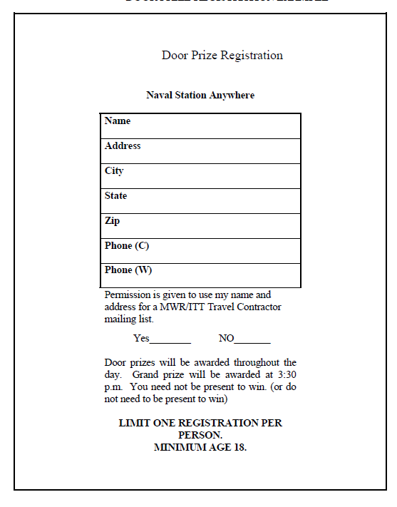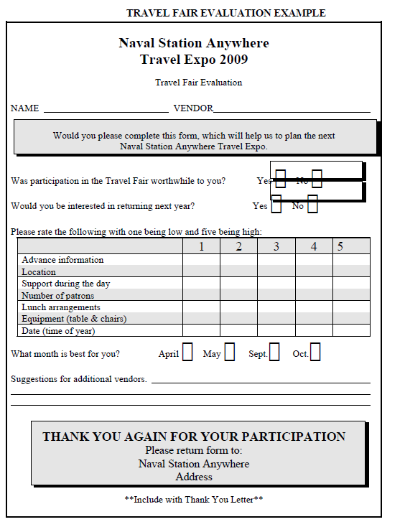

Sample Letter of Invitation
