Military Ticket Program 24/25



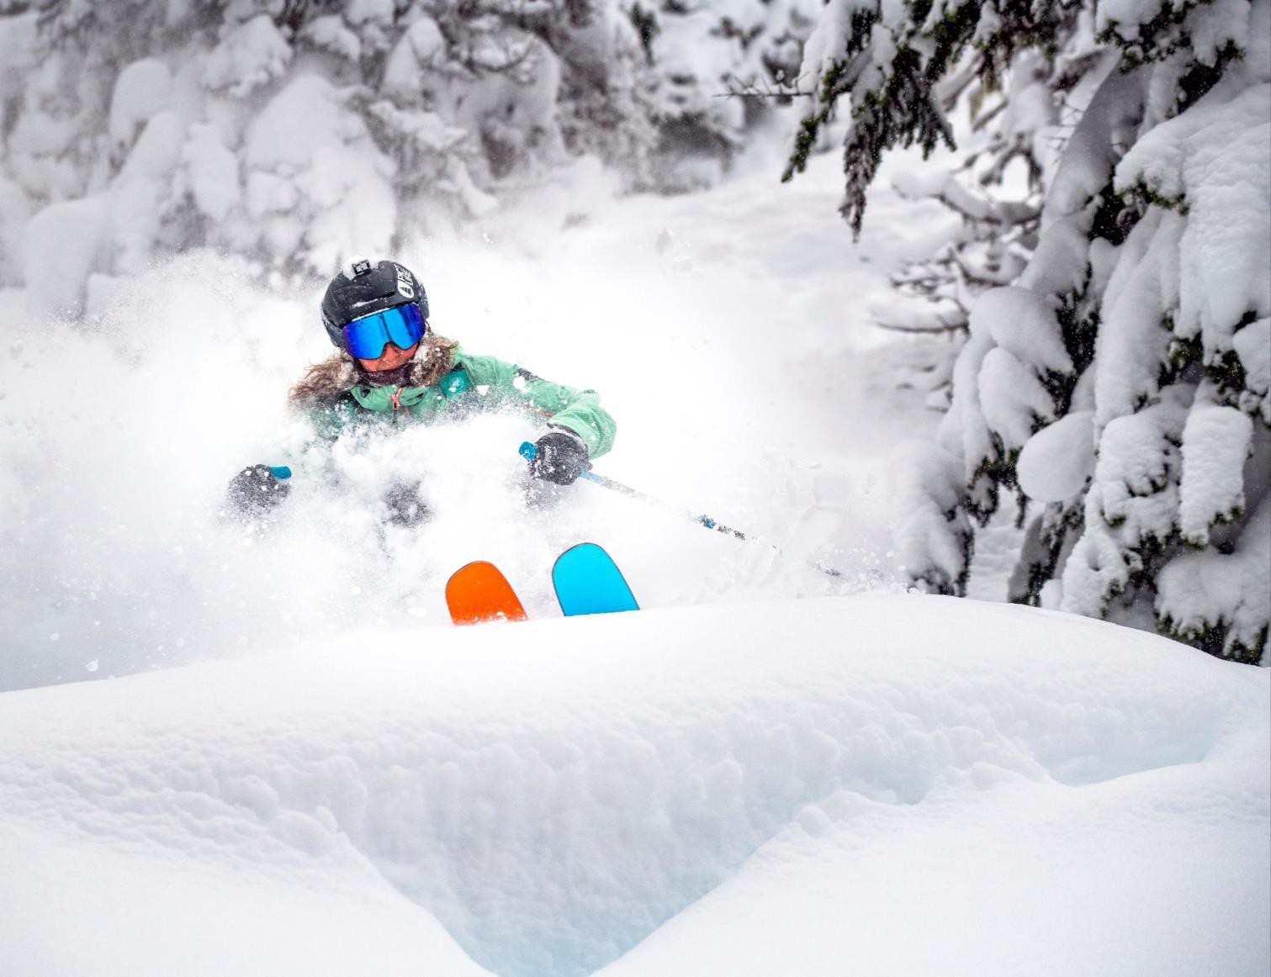
Ikon Pass + Military Sales

Ikon Pass partners with the MRW and the Military Ticket Program to offer specially discounted rates on the Ikon Pass and Ikon Base Pass. These are ski passes for the 24/25 winter season that give you access to 50+ destinations worldwide.

MTP offers:
Ikon Pass = $799 (regular $1249)
Ikon Base Pass = $519 (regular $869)

Military Discount: Who Qualifies?

Qualifications:
- Adults (23 years or older)
- Young Adults (13 to 22 years old)
- Valid for active duty, retired (20+ years of service), reserve service members, and 100% disabled veterans.
- Must show valid military ID with name, branch of service, and current dates to qualify.
- Spouses and dependents (26 years or younger) also qualify with proof of valid dependent military ID.
- There is no military discount for child passes.
- There is no discount for veterans, military
contractors, or DOD employees.

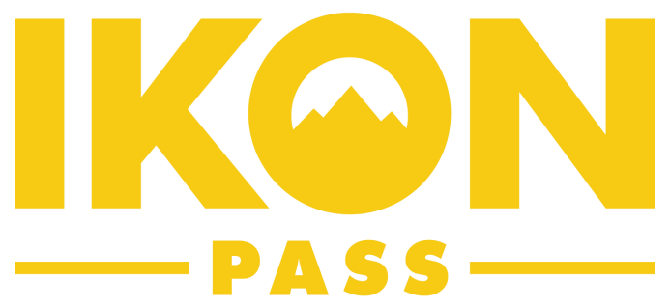
Ikon Pass Military Discount - Eligibility Requirements
Eligible service members are Active Duty, Retired, or Reserve/National Guard members of the
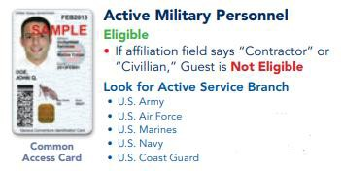
U.S. military including, Air Force, Army, Coast Guard, Marine Corps, Navy, and Space Force. Spouses and dependents of the service member also qualify. 100% Disabled Veterans are eligible. A valid military ID must be presented in order to purchase an Ikon Pass or Ikon Base Pass.
- U.S. Space Force

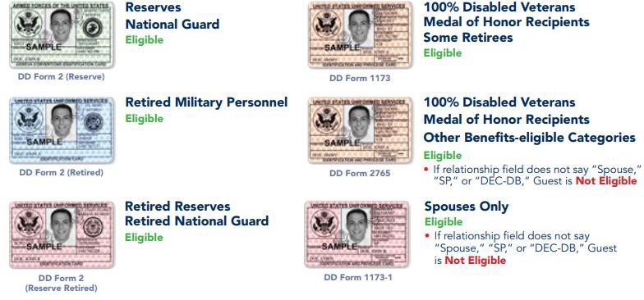
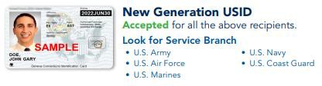
Individuals that are not eligible for this offer: Veterans, DOD Civilian Employees, U.S Public Health Service employees (USPHS) and National Oceanic and Atmospheric Administration Employees (NOAA).

- U.S. Space Force

Ikon Pass – What is Included

Unlimited (NO Blackouts) |  | 7 Days (NO Blackouts)
Big Bear | Snow Valley | Arapahoe Basin | Killington/Pico | Sun Valley
Blue Mtn - ON | Snowshoe | Alta/Snowbird | Kitzbuhel | Sugarloaf
Copper | Solitude | Alyeska | Loon | Sunday River
Crystal | Steamboat | Aspen Snowmass | Lotte Arai | Taos
Eldora | Stratton | Blue Mtn - PA | Mt Bachelor | The Highlands
June | Sugarbush | Big Sky | Mt Buller | Thredbo
Mammoth | Tremblant | Boyne Mtn | Coronet Peak,  Remarkables, Mt. Hutt | Valle Nevado
Palisades Tahoe | Winter Park | Brighton | Niseko | Windham
Schweitzer |  | Camelback | Panorama | Zermatt
 |  | Chamonix | Red Mtn
 |  | Cypress | Revelstoke
 |  | Deer Valley | SkiBig3
 |  | Dolomiti SuperSki | Snoqualmie
 |  | Grandvalira | Snowbasin
 |  | Jackson Hole | Sun Peaks

Ikon Base Pass – What is Included

Unlimited (No Blackouts) | Unlimited w/ Blackouts | 5 Days w/ Blackouts |  | 5 Days NO Blackouts
Big Bear | June | Alyeska | Red Mtn | Arapahoe Basin
Blue Mtn - ON | Mammoth | Big Sky | Revelstoke | Chamonix
Copper | Palisades Tahoe | Blue Mtn - PA | Schweitzer | Dolomiti SuperSki
Eldora | Solitude | Boyne Mtn | SkiBig3 | Grandvalira
Snow Valley | Stratton | Brighton | Snoqualmie | Kitzbuhel
Snowshoe | Sugarbush | Camelback | Snowbird (no Alta) | Lotte Arai
Tremblant |  | Crystal | Steamboat | Mt Buller
Winter Park |  | Cypress | Sugarloaf | Coronet Peak, Remarkables,  Mt. Hutt
 |  | Killington/Pico | Sun Peaks | Valle Nevado
 |  | Loon | Sunday River | Zermatt
 |  | Mt Bachelor | The Highlands
 |  | Niseko | Thredbo
 |  | Panorama | Windham

Blackout Dates
Northern Hemisphere
12/26/2024 - 12/31/2024
1/18/2025 - 1/19/2025
2/15/2025 - 2/16/2025
Southern Hemisphere (Thredbo Only)
7/6/24 – 7/21/24
7/5/25 – 7/20/25

*NO ACCESS TO: Aspen Snowmass, Jackson Hole, Sun Valley, Deer Valley, Alta, Snowbasin, and Taos


Pass Benefits

Benefit | Ikon Base Pass | Ikon Pass
Friends and Family Tickets | 8 | 12
Food, Beverage, Retail | 10% | 15%
First Tracks | Early lift access on select days | Early lift access on select days
The North Face | 20% off $200 purchase on select footwear/apparel | 20% off $200 purchase on select footwear/apparel
Db Bags | 20% off – 1 time purchase | 20% off – 1 time purchase
Ship Skis | Up to 20% off service. | Up to 20% off service.
Blenders Eyewear | 30% off – 1 time purchase | 30% off – 1 time purchase
POW | 1-year free membership | 1-year free membership
Woodward Summer Camp (spring only) | Save $200 on overnight camps and $100 on day camps | Save $200 on overnight camps and $100 on day camps
Under Canvas | Exclusive Discount | Exclusive Discount
F45 | $14 for a 14-day trial | $14 for a 14-day trial
Heli Bucks | $200 per day booking/in-lodge credit at select times + locations | $200 per day booking/in-lodge credit at select times + locations
Summer Bike Lift | One complimentary bike lift ticket | One complimentary bike lift ticket
Alterra Mtn Co Community Foundation | Portion of pass price donated | Portion of pass price donated

Summer Bike Benefit

One complimentary bike lift ticket per 2024-25 Ikon Pass
Restricted holidays at all participating destinations (July 4 – 7 and August 30 – Sep 2; 8 total days) Applies to Ikon Pass, Ikon Base Pass, Ikon Base Plus Pass. Ikon Session Pass is excluded
All age categories eligible Benefit will be direct to window Non-transferrable
Participating Destinations (16)
- Revelstoke, Sun Valley, Solitude, The Highlands, Snowshoe, Panorama, Snowbasin, Stratton, Loon, Schweitzer, Sun Peaks, Steamboat, Aspen Snowmass, Brighton, Mammoth and Kitzbuhel

Spring Access – Buy Now Ride Now

Destination | Ikon Pass | Ikon Base Pass
BBMR | Immediately | Immediately
Snow Valley | Immediately | Immediately
Blue Mtn | Immediately | Immediately
Snowshoe | Immediately | Immediately
Solitude | Immediately | Immediately
Stratton | Immediately | Immediately
Sugarbush | Immediately | Immediately
Crystal | Immediately | No Access
Schweitzer | Immediately | No Access
June | 4/1/2024 | 4/1/2024
Mammoth | 4/1/2024 | 4/1/2024
Palisades Tahoe | 4/1/2024 | 4/1/2024
Winter Park | 4/1/2024 | 4/1/2024
Steamboat | 4/8/2024 | 4/8/2024 (Doesn’t count towards visits in 24/25)
Tremblant | 4/8/2024 | 4/8/2024
Deer Valley | 4/8/2024 (Doesn’t count towards visits in 24/25) | No Access

Summer Access

- Northern Hemisphere summer access includes scenic chair lift/gondola rides at select destinations below.
- Extra discounts can be found here: https://www.ikonpass.com/en/summer-at-the-mountains.
- Southern Hemisphere summer access is dual season.
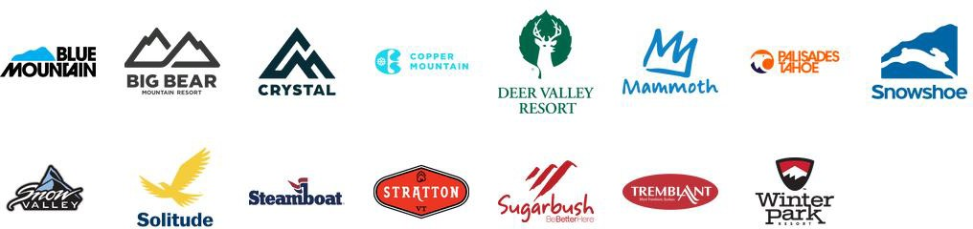
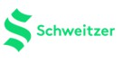

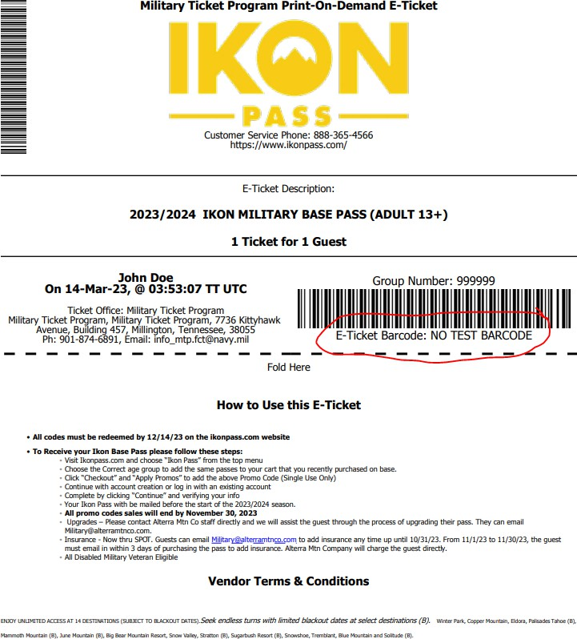
Purchasing On-Base
Guest will buy their pass direct from your location.
In return, they will receive a E-Ticket pictured
here.
The E-Ticket has a unique, single use promo code located under the barcode. It is a 12-character combo of letters and numbers.
The guest then takes that promo code and redeems it on IkonPass.com. The code will register the pass as $0 since it was pre-paid at the military installation.
The guest MUST redeem their promo code in
order to activate their pass.

Activating the Pass
The E-Ticket has specific directions for the guest to follow. Recommended way to redeem is through:
https://account.ikonpass.com/promocode

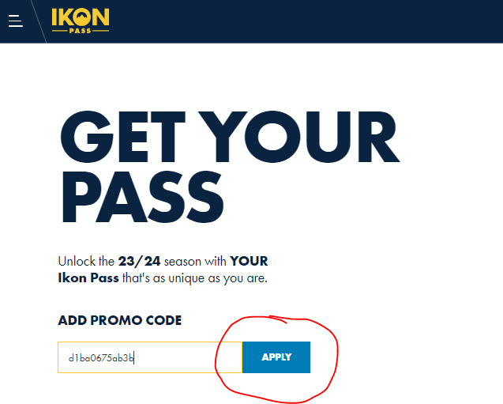

IKQN
-PA55-

AVAiLABLE PASSES FOR: D1B,A0675AB3,B
lliis code is va d for 2:4/25, lkoll'ilPcss. Discounts will be ap lied,at d1edkout.

2,4/25 IIIKON PASS
lncil'l.1,des access to 50+ destill'latioll'ls wi h INO SLACKO'IJiliS.

Adult
[ 2:r-)

Y:01u1ng Ad ult
I • i3-22I

& [ll1Jssin9 "en.prod dsjko • ,;:i - -2A25se-stii'c·oo_,.,,o:rn· • trc forti ]

IFREE
Reg.ri:e: $1,.2.4.9

IFREE
Reg. rice: S929

ADDTOCART

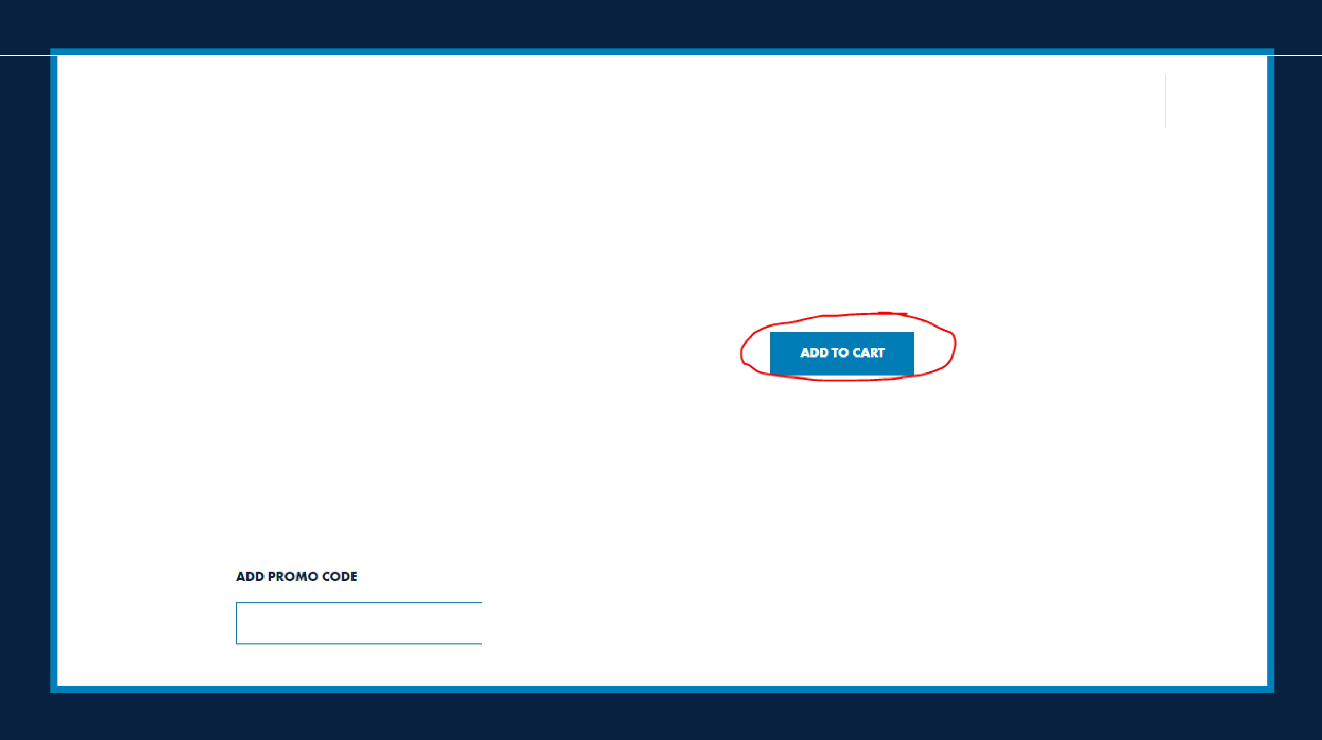

APPLY

IKQN USD/EN SHOPPASSES
=
- ASS-

AVAILABLE PASSES FOR: DIBA0675AB3B
Thh code i:s. valid l-or 24/25 Ikon Poss. Oi.:KoLinh will be cpplied at checkout.

24/25 IKON PASS
Includes access tc 50+ destinations with NO BLACKOUTS

Adult
[ 23+

Young Adult
[ 13-221

& [missingnen.produdsjkonpas 2A25.1estriclio.n_ wamtng• ln:mslotionJ

FREE
i.eg. flrke: S1,249

FREE
Reg. Price: S929

+
ADDTOCART

0 You have redeemed !he maximum number oJ passes valid for lhis promotion code. Please en!er c new code to purchase additional pa:!>..:ies.

ADD PROMO CODE
1911



I ITEM IN CART EhP:IE CLOSE X

YOURCAIRT' ORDER.SUMMARY

24/25 IKON PASS X
 |  | SAVINGS: | .$,1,249.00
Adult (Ase 23+)  Ikon Military Program | $1,249.00  - Sl,249.00 | TAXES& FEES: | $0.00

SUBTOliAL:
$1,249.00

D lnj1ury llns,urance: Cov.ers your d.educ · e1 plu:Si.n- and oo,·-cl-neiwork medical costs.t
up o $25k

+ S6400
TOTALusD

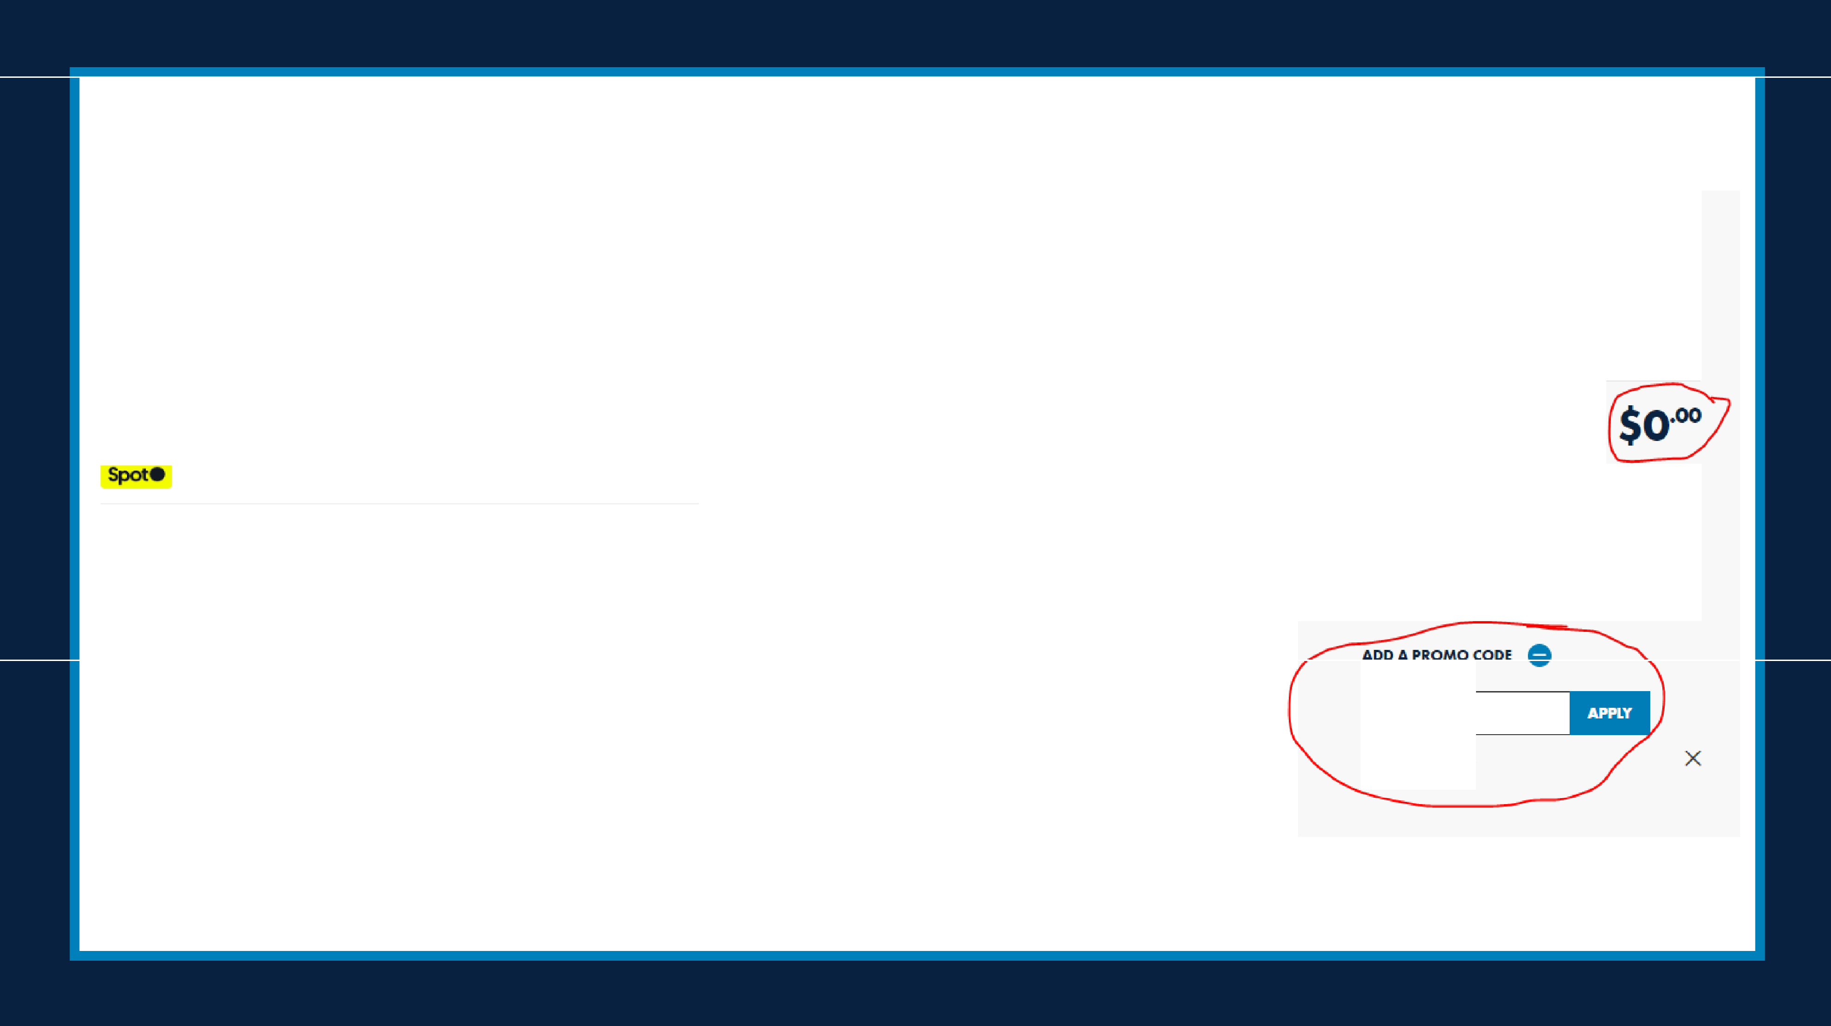
FREE
PROCEED TO CHECKOUT )

Applicable credits and eligible remewal, "'me, milit,ny, or college discounts will be applied ,at check.oul. Selecled products and posses may not qualily lo, discounts.

Dl BA0675AB3B

Spot Insurance

Direct service member to purchase Spot Insurance through Ikon Pass directly. Best to email military@alterramtnco.com to purchase.

Pass Protection: protects the price of the pass should the unexpected happen
- Always 7.25% of the pass price – cannot be bought with a $0 promo code.
- Can be purchased at any time until Oct. 31st.
- Post Oct. 31st, it should be purchased the day of purchasing the pass.

Injury Insurance: helps pay for medical bills if the person gets injured while using their pass
- Can be purchased with a $0 promo code.
- Flat rate of $99 per Ikon Pass or Ikon Base Pass.
- Can be purchased at any time.

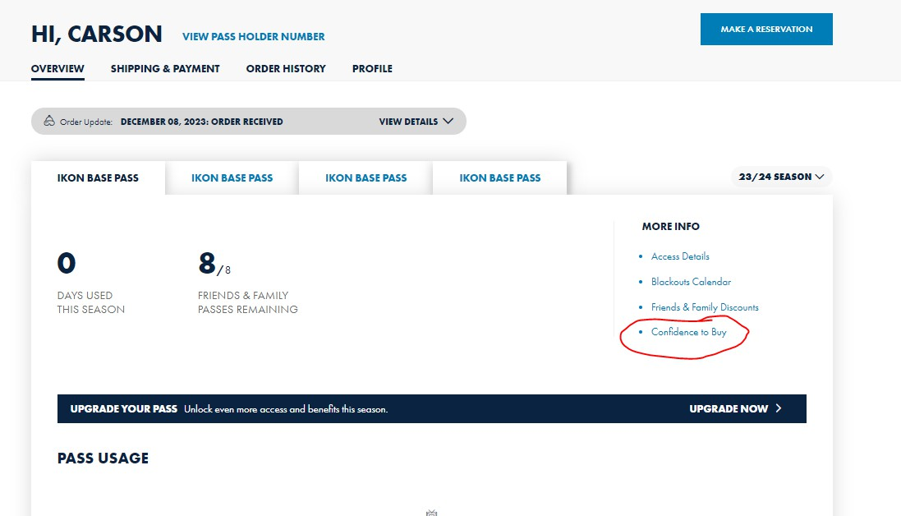
Confidence to Buy

ELECT TO DEFER BY DECEMBER 12, 2024

  - Guest can defer their unused 24/25 pass at any time until 12/12/24.
  - They must redeem the promo code on IkonPass.com and then go to the MyAccount page, click “Confidence to Buy” and hit the elect to defer button there.
  - They will receive a credit for what they paid in
their IkonPass.com account in spring 2025.
  - They can apply their credit to an Ikon Pass of their choice for the 25/26 season.

Misc. Notes

All physical passes will be printed and mailed to the guest starting in the fall – they must redeem their code, have a valid mailing address and photo for their pass in their IkonPass.com account.

November 30th, 2024 is the LAST day for the Military Ticket Program sales.

Any guest need assistance or have questions, please refer them to military@alterramtnco.com

Participating locations are listed on our website here: www.ikonpass.com/military
If you would like your location to be listed on the website, please email us at military@alterramtnco.com.

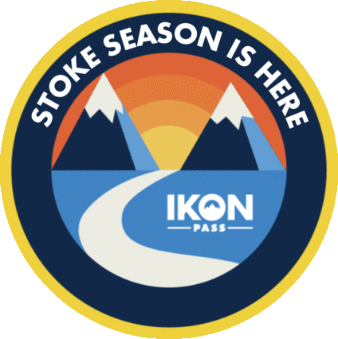
Thank You!

