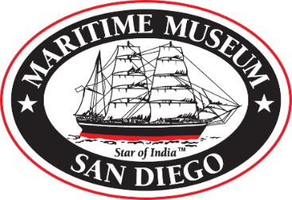

Maritime Museum of San Diego 2025 update 072225

Link where marketing materials may be found if available:

This is the google drive link to find all content.
https://drive.google.com/drive/folders/1xYhzCDDqAu2ljzjOhVuV2R80v1-Jtn7B?usp=drive_link

However, if you need digital content with links to our website and Youtube videos, those are below.

Here is a summary of content provided
Maritime Museum of San Diego general 3-fold brochure
New Swift boat Naval History bay tour rack card
On the water adventure and museum experience rack card
Videos – note all of these videos live on our website and have page url’s.

Other options
MMSD Experience overview video.(The Youtube link is below OR see video file on the above link.)
https://youtu.be/jvs1AAzAbeo
https://sdmaritime.org/

Naval History Bay tour video (The Youtube link is below OR see video file on the above link.)
https://youtu.be/ltcdux1Z9N0
https://sdmaritime.org/visit/on-the-water-adventures/pcf-816-swift-boat-tour/

Pilot Boat Bay tour video (The Youtube link is below OR see video file on the above link.)
https://youtu.be/vCexfiPU4VQ
https://sdmaritime.org/visit/on-the-water-adventures/historic-bay-cruises-aboard-pilot/

Tall Ship Adventure Californian Sail video (The Youtube link is below OR see video file on the above link.)
https://youtu.be/-hBIK6B9kfk
https://sdmaritime.org/visit/on-the-water-adventures/tall-ship-adventure-aboard-californian/

San Salvador Adventure Sail video (The Youtube link is below OR see video file on the above link.)
https://youtu.be/axifD0r5kKA
https://sdmaritime.org/visit/on-the-water-adventures/san-salvador-sailing-adventure/

Private Venue Considerations:
https://youtu.be/hLsae_jVmLk
https://youtu.be/9N81EsEr-FM

