

WebCentral Getting Started Guide

N9 CMS

Table of Contents

Table of Contents

Logging in with Single Sign On.............3-4
Understanding the WebCentral Homepage................................................5
Navigating in WebCentral .....................6-8
Menu Selector…………………...….6
Support…………………………...….6
Approvals…………………………....7
Account Settings………………...….7
Understanding Adaptive Content…….9-10
Direction of Content……..9
Why Adaptive Content…..10
Content Explorer……………………..….11-17
Programs……………………...….12

Adding a Program……...13
Events ...................................... 18
News……………………………..19

Site Planner ............................................ 20-24
Add. Navigation Selections…………21
Managing WebPages................ 22-24

Publish and Approve Pages…25-29
Redirect Links...........30-32
Components…………………...33
Smartlist………………………...34-43
Smart Button…………..45

1

Logging in with Single Sign-On (SSO)

Accessing WebCentral (CMS) is simple but will require a few one-time steps to get started. Before you can access your account you will need to load Google Authenticator on your mobile phone or tablet, see Google Authenticator setup for more information.

Go to your designated WebCentral URL and Accept the User agreement.
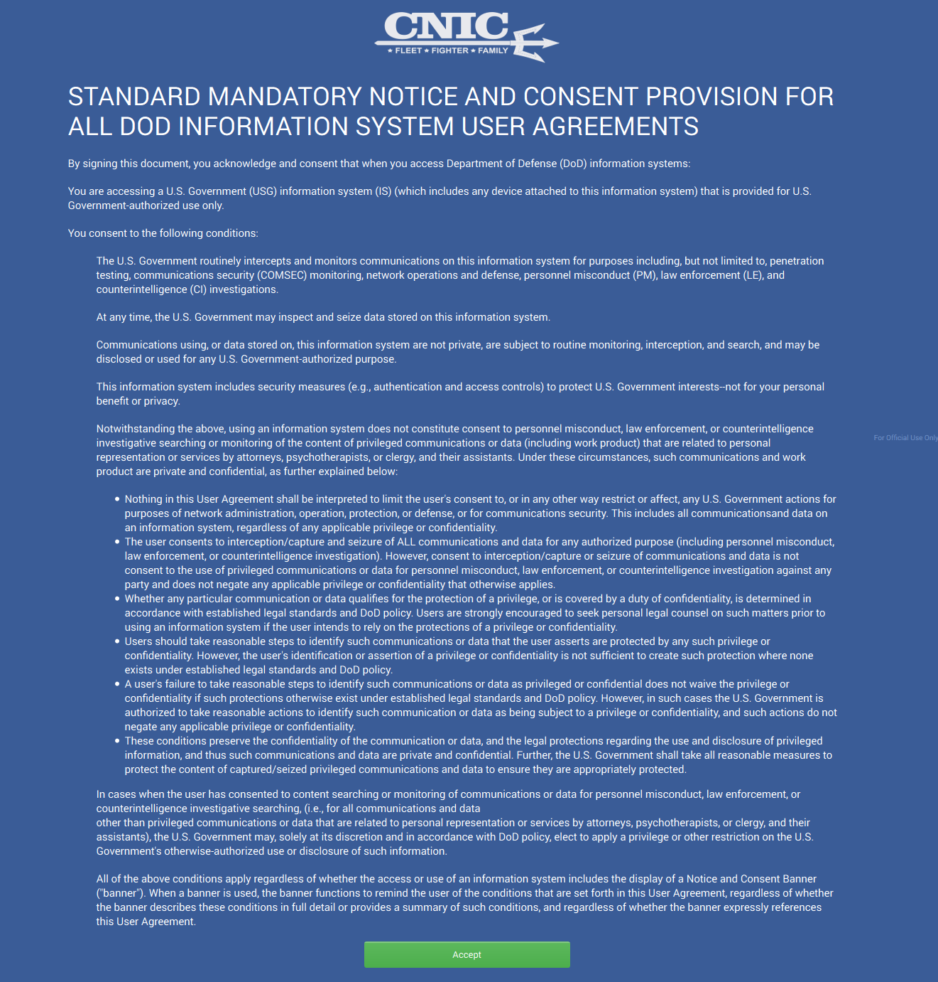

Signing in with Multi-Factor Authentication is easy.
  - Go to the sign-in page and enter your username and password like you normally do.

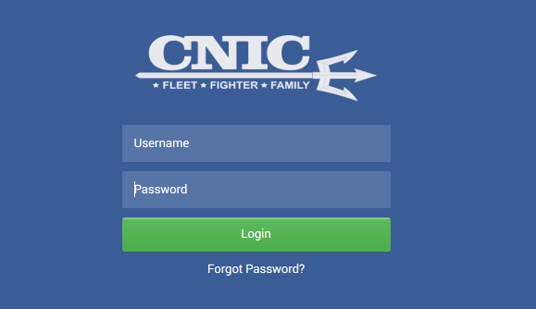
  - Then you’ll be asked for a six-digit code, which you'll get from your phone, in the Google Authenticator. If you have not set this up, please return to the Google Authenticator section of this document.

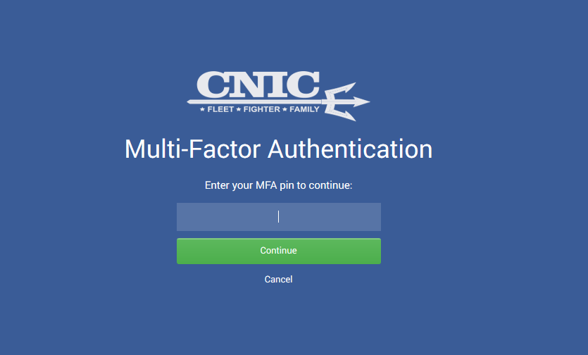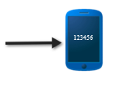

2
Understanding the WebCentral Homepage

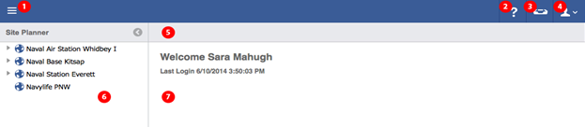

Circle | Element | Description
1 | Menu Selector | Access various workspaces, e.g. Site Planner, Content Explorer, Media Manager, Taxonomy Browser, Marketing, Administration
2 | Support | Links to support service desk
3 | Approvals | List of content items that are pending approval
4 | Account Settings | Profile/settings for logged in user
5 | Toolbar | Contains menu of buttons appear that are relevant to the Main Content Pane below
6 | Left Panel | Contains navigation "Tree" for the current workspace
7 | Main Content Panel | Displays the content selected in the left navigation "Tree"
Side panels can be collapsed when additional screen real estate is required. To collapse a side panel click the arrow in the Toolbar directly above the panel. When the panel is minimized clicking once on the bar will open the panel for quick access. The panel will collapse again when not in use. To lock the panel in the open position click the arrow in the toolbar again.

3

Navigating in WebCentral

Menu Selector
Found in the top left of your screen. This allows access to various workspaces. For specific definitions please refer to the individual workspaces defined in this document
Workspaces: Site Planner, Content Explorer, Media Manager, Taxonomy Browser, Marketing, and Administration.
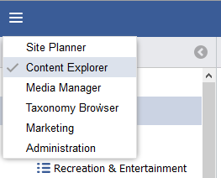

Support
Use our Support page to search for solutions, report a bug, report system problems, or request assistance.
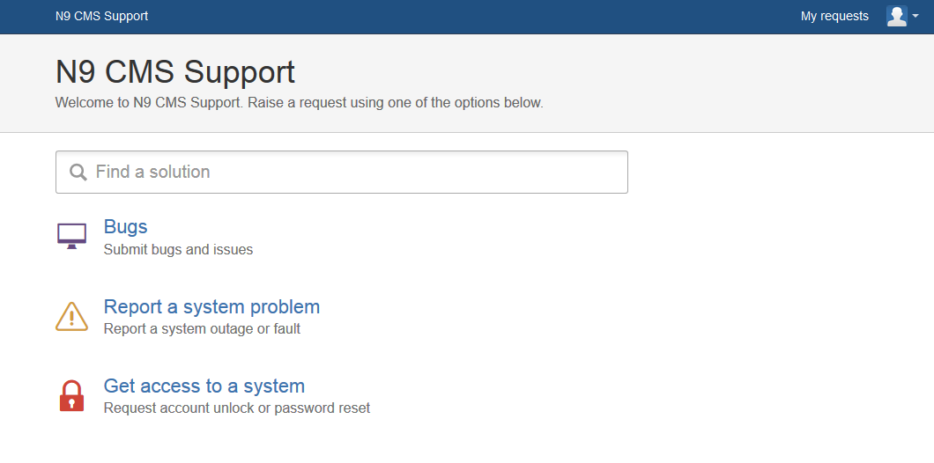

Approvals
Approve changes made to your content and push publications with just a few clicks.
Pending Approvals display as a red circle on your Approval icon.

- Tips: The number of pending approvals displays in the red circle.

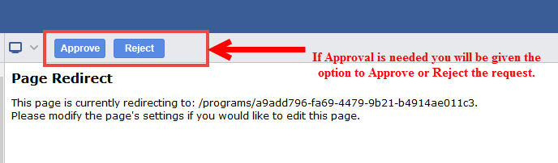

- Tips: In order to Approve users must have Privileges. If you find that you do not have sufficient privileges please contact your administrator.

Profile
Access to your Profile Details and Password changes can be updated here.

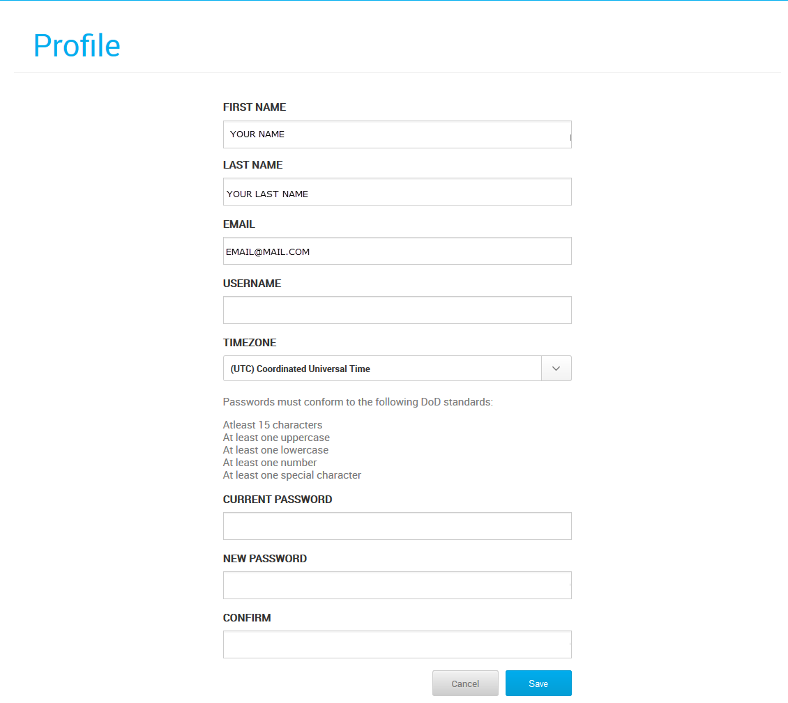

4
Adaptive Content

The Direction of Content
The definition of content is changing. We now have more mediums than ever to apply our content and in the not so distant future we will see those channels of content change once again. This is why it’s so incredibly important to have our content ready to go in any context.

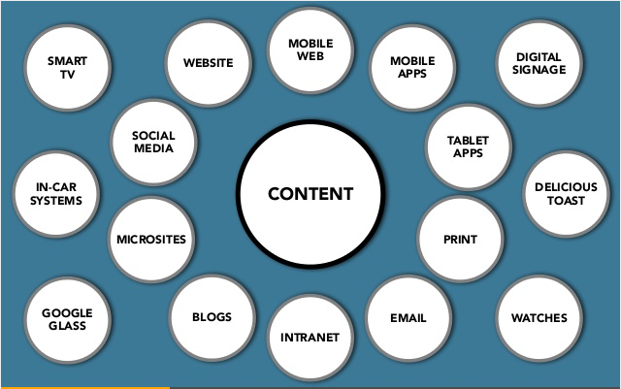

Table 1-1: Four Requirements of Adaptive Content
 | Reusable Content |  |  | Content that has been developed to maximize reuse across marketing channels
Structured content |  |  | Discrete content chunks can be combined in different ways for different channels
Presentation-independent content |  |  | Design decisions can be made by the platform, rather than having style and format imposed on the content.
Meaningful metadata |  |  | Tags, groups, and date information can be used to filter content

Why should we be doing this? Everybody else is doing it…..


5
Content Explorer
 We recommend that you build your database content first, in Content Explorer. For Video Tutorials see our Knowledgebase.

The Content Explorer will be the bread and butter of your database. All the detailed information of your programs, facilities, news and events are entered here. Think of this as your central database. All information entered here can be pulled into various channels.

Please note, the more complete your data is the better your resources will be for your Patrons!

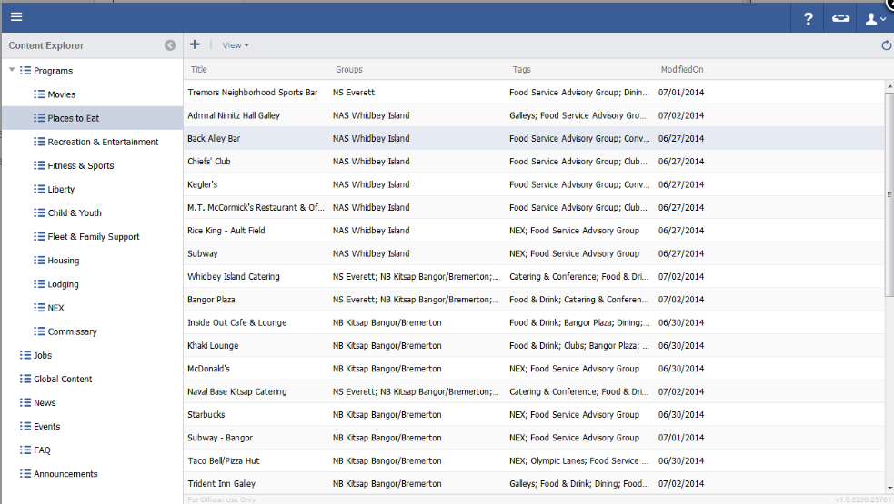

Programs
The Programs Section contains locations and their details divided up by Program sub-sections.
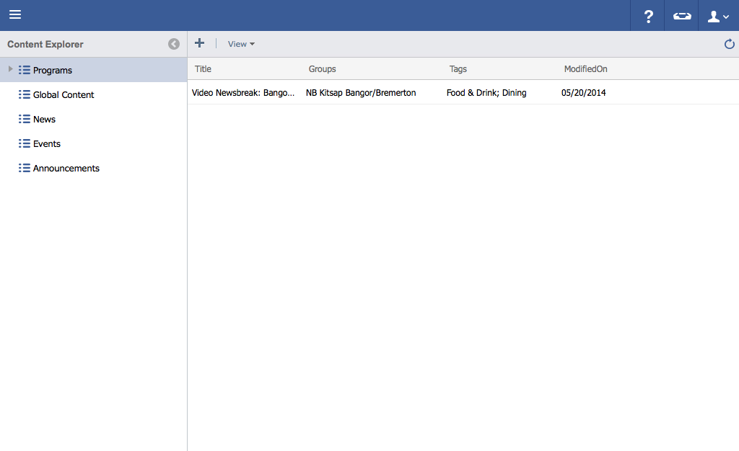

Tips: See our WebCentral KB for detailed instructions

Adding a Program
- Click on the menu icon in the top left header area.
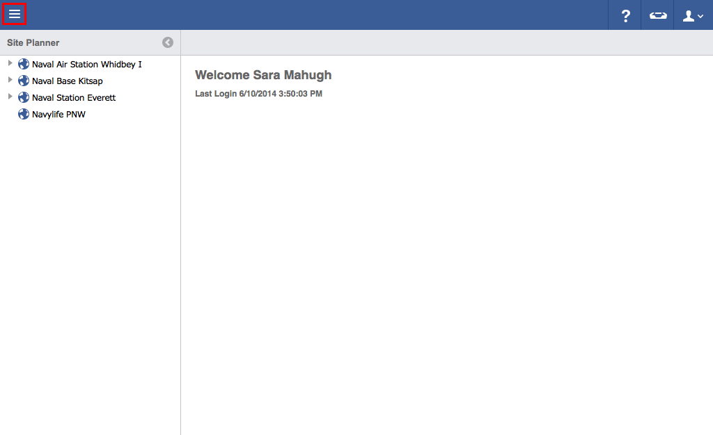
- Click "Content Explorer".
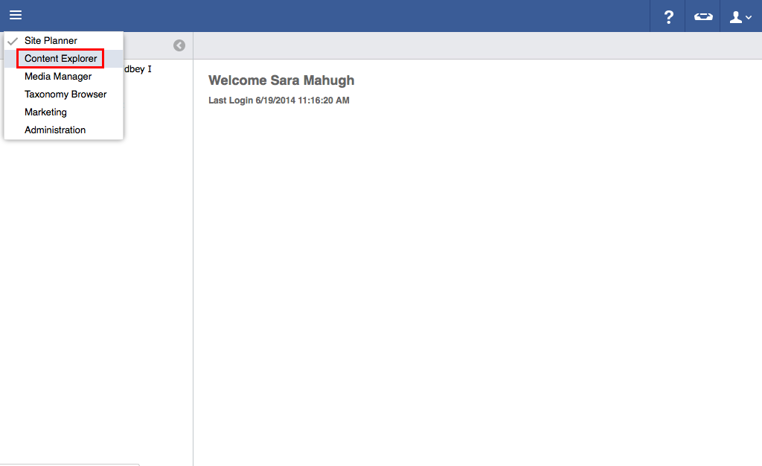
- Click the arrow next to "Programs".
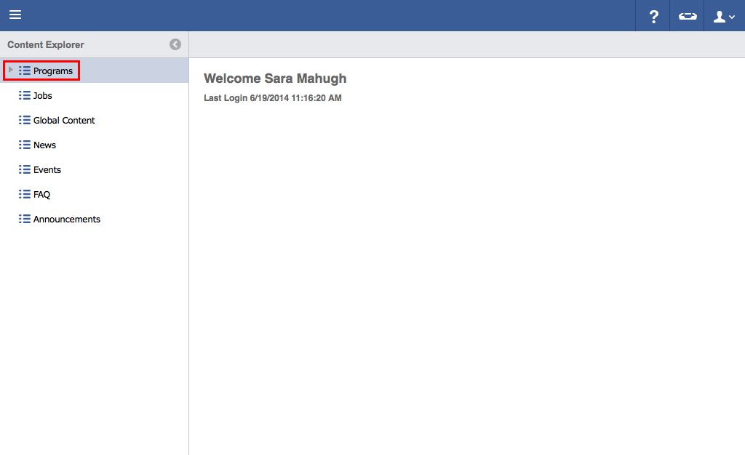
- Select a category to add to (In this case, Movies).
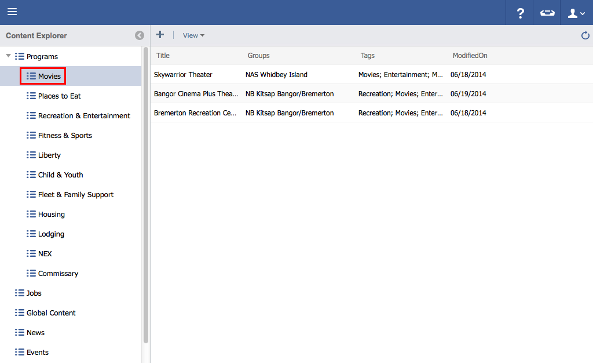
- Click the "Plus" icon.
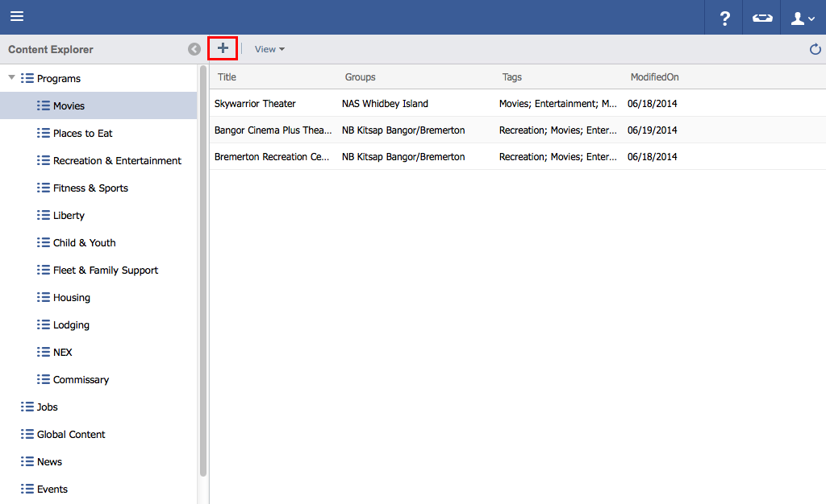
- Add program details.
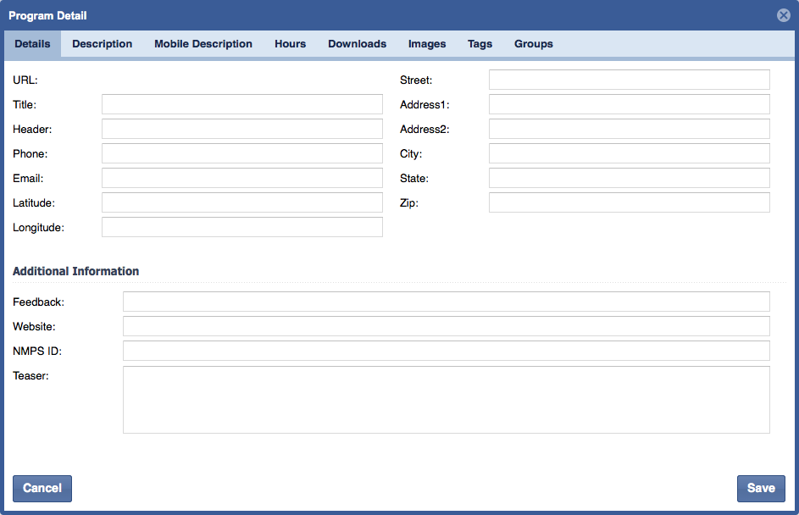
- Continue adding additional information by clicking on other tabs (Such as, Description, Mobile Description, Hours, Downloads, Images, Tags, and Groups).
Click "Save".
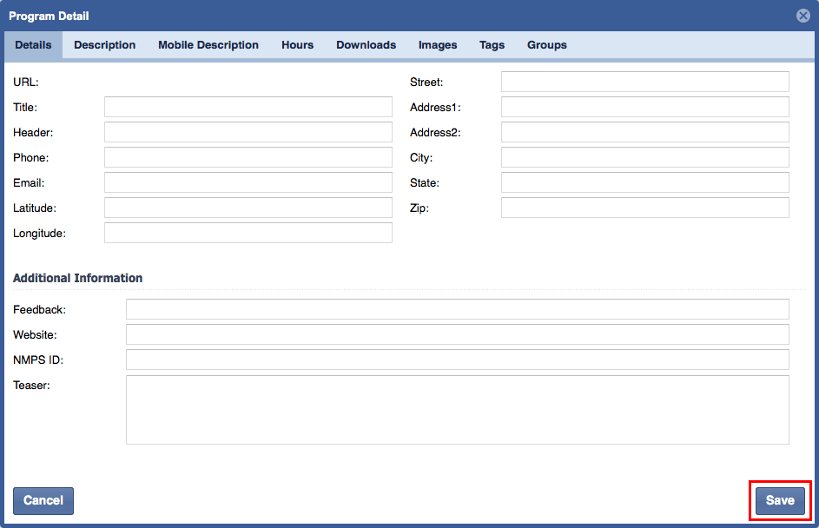

Events
The Events Section allows the user to create, manage and distribute Events that can be viewed on the Website and Mobile Apps.
Events are made up of:
- Title
- Image
- Display Date
- Archive Date
- RSVP By Date
- Event Start Date
- Event End Date
- Start Time
- End Time
- Location/Address Information
- Email
- Phone
- Teaser Text
- Event Description Text
- Downloads
- Tags
- Group Permissions

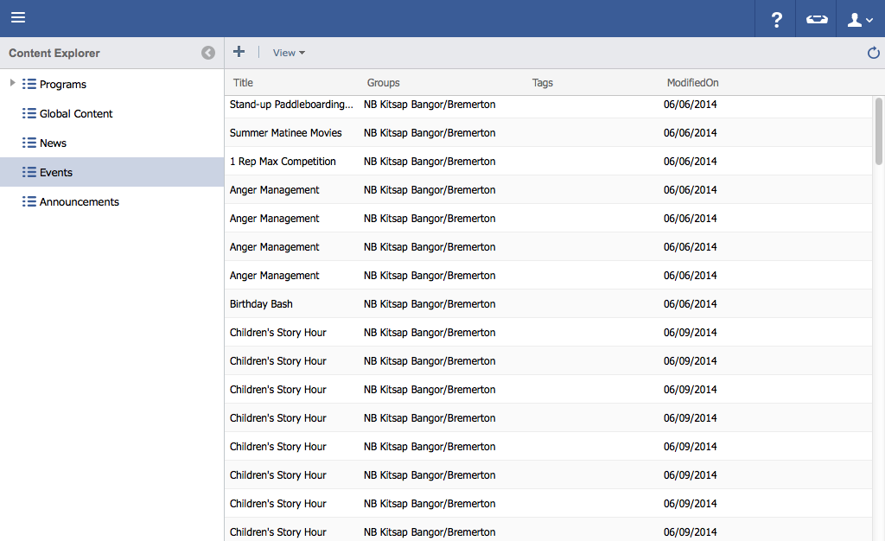

News
The News Section allows the user to create, manage and distribute News Articles on the Website and Mobile Apps.
News Items have:
- Title
- Image
- Display Date
- Archive Date
- Teaser Text
- Article Text
- Tags
- Group Permissions

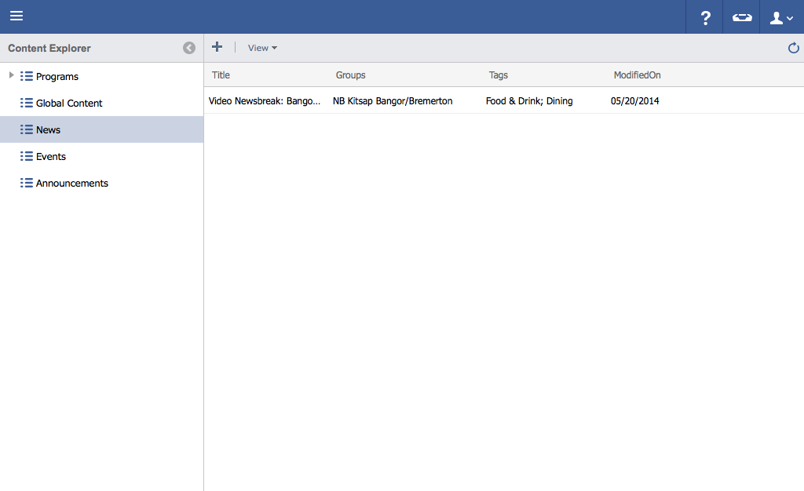

6
Site Planner

We recommend that you build your data in Content Explorer prior to building in Site Planner.

Site Planner is a user friendly tool to help you manage how database content will display on the web. In this tool you can Publish and Approve pages and redirect to webpages outside of your organization.

Site Planner Additional Navigation Selections
These options appear once you enter the Site Planner workspace and select content in the navigation "Tree".

Page Settings
Shows detailed information on the current content selection.
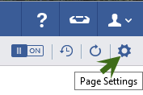
Refresh Page
Once selected this will update the page with any saved changes or modifications you may have made.
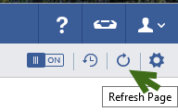
Load History
This will display the current and previous versions of your content.
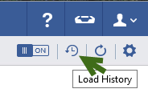

Managing Webpages

Adding a Page
- In the Site Planner, click on the "+" button of a item to add a page within its section.
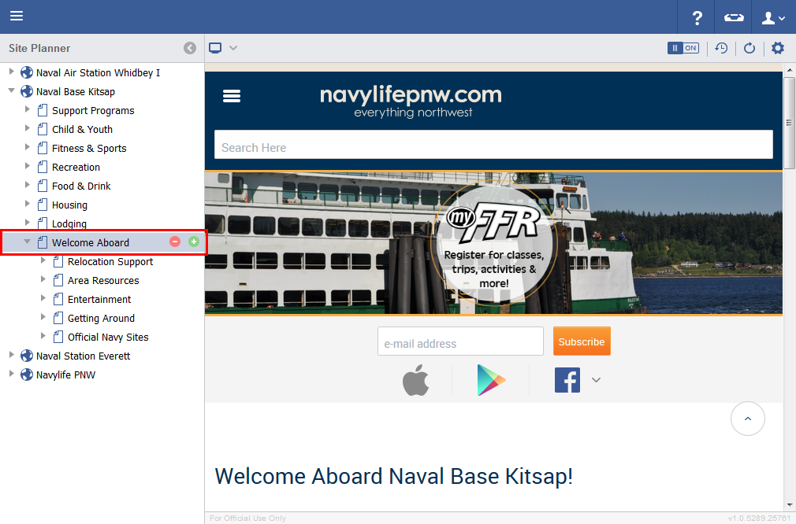
- Enter a Page Title and click OK.
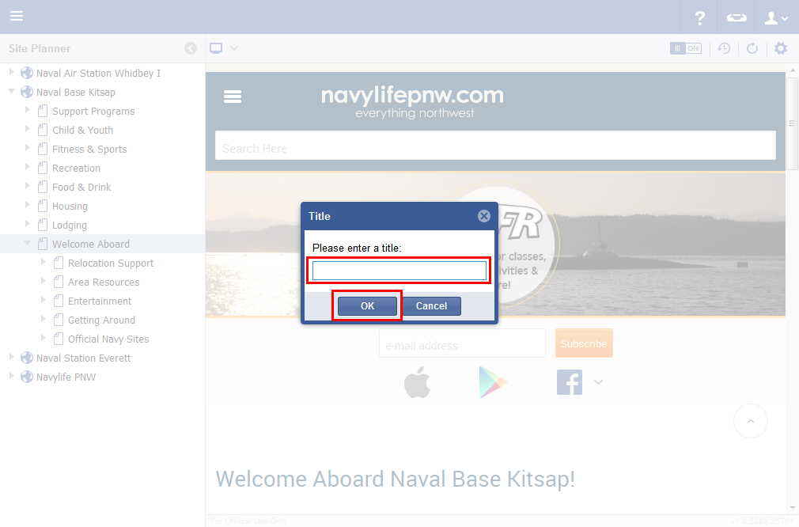
- The page has now been created.
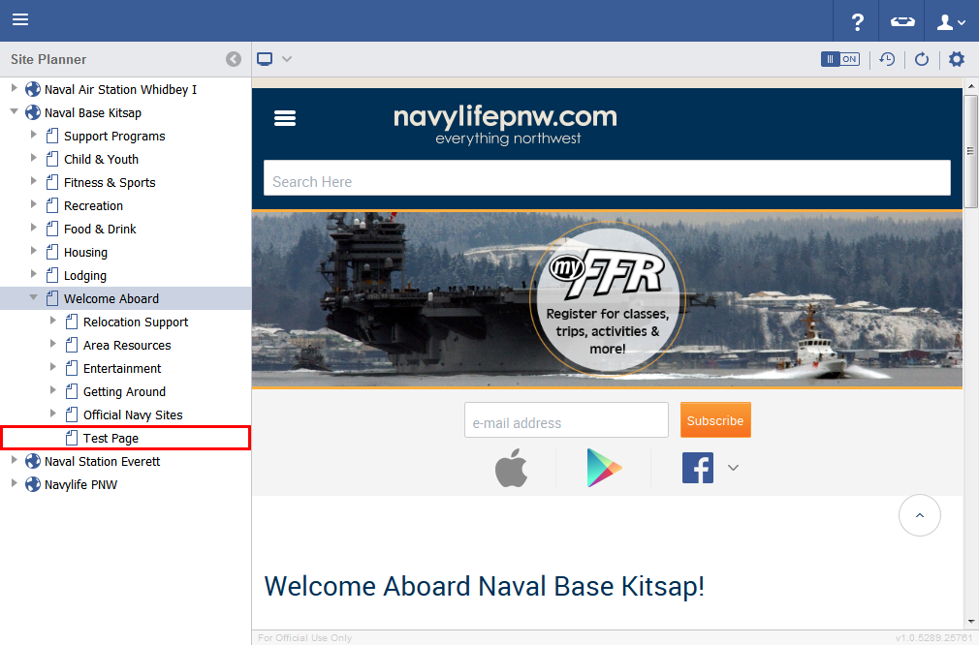

7
Publishing and Approval Process

- In the Site Planner, select a Page to be edited.
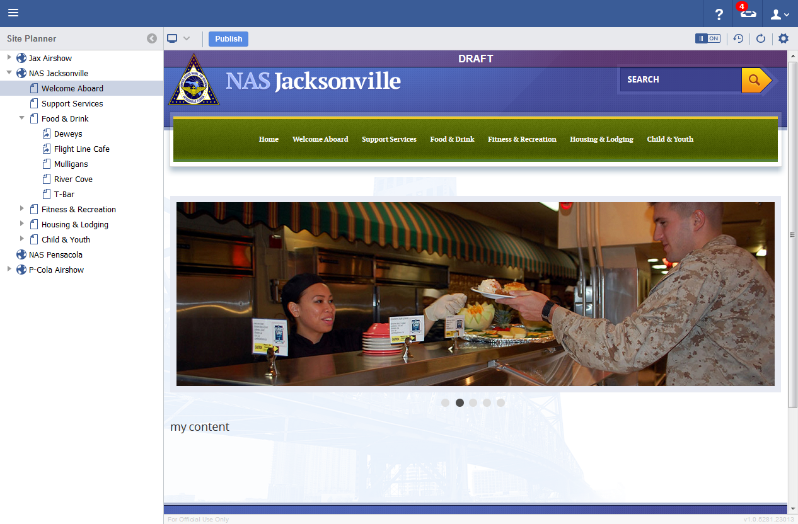
- Click on the Publish button at the top of the Admin once desired changes have been saved.
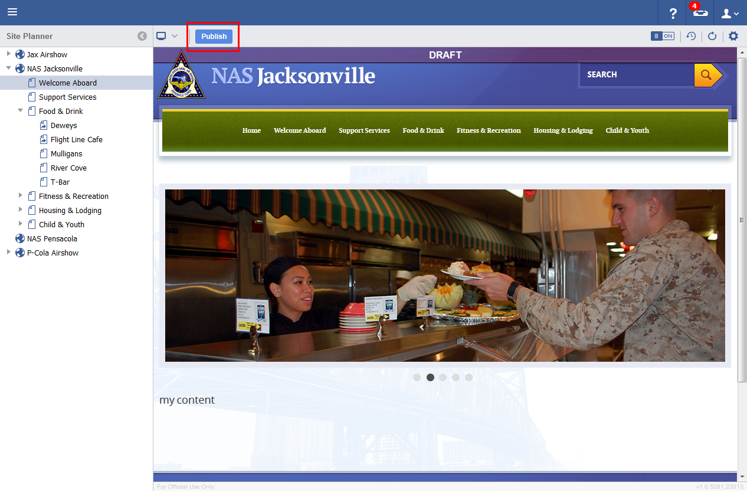
- Click on the OK button when the Notification Alert comes up.
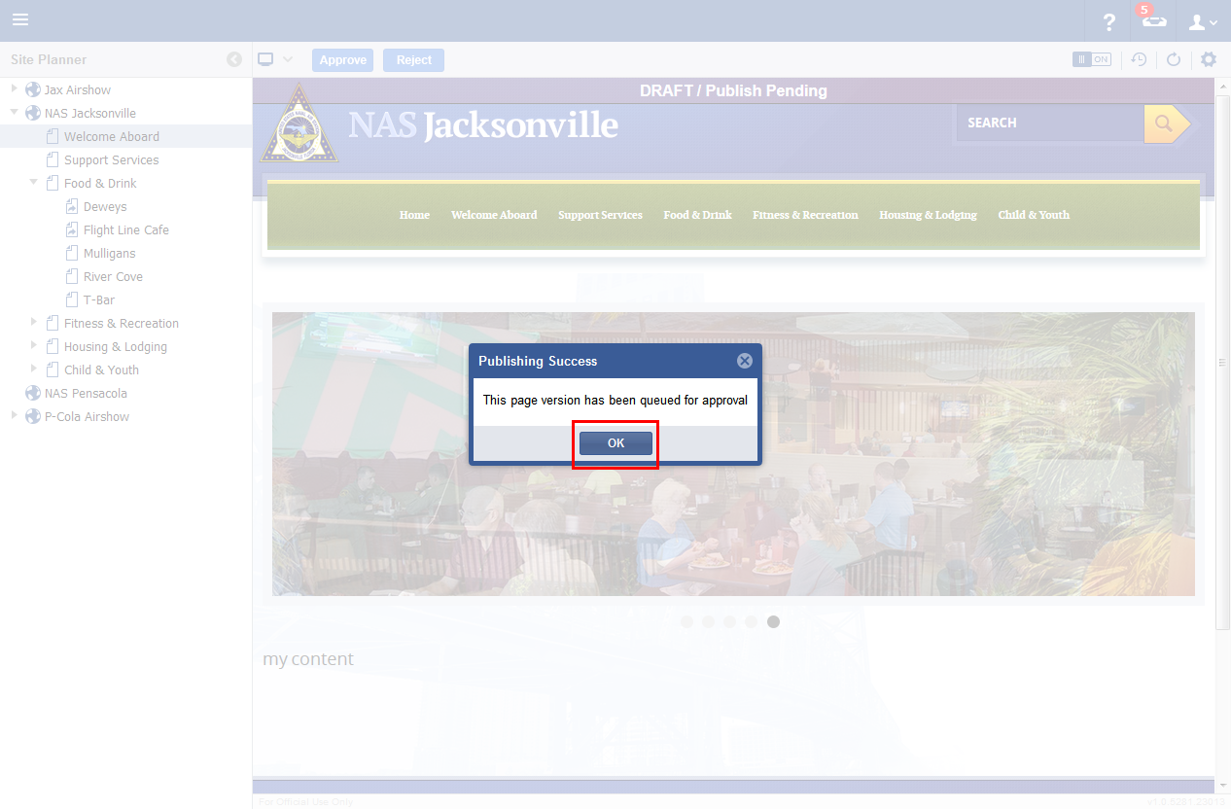
- The page is now queued for Approval by the appropriate Administrator. Users with applicable permissions will be able to Approve changes. Click the Approve Button.
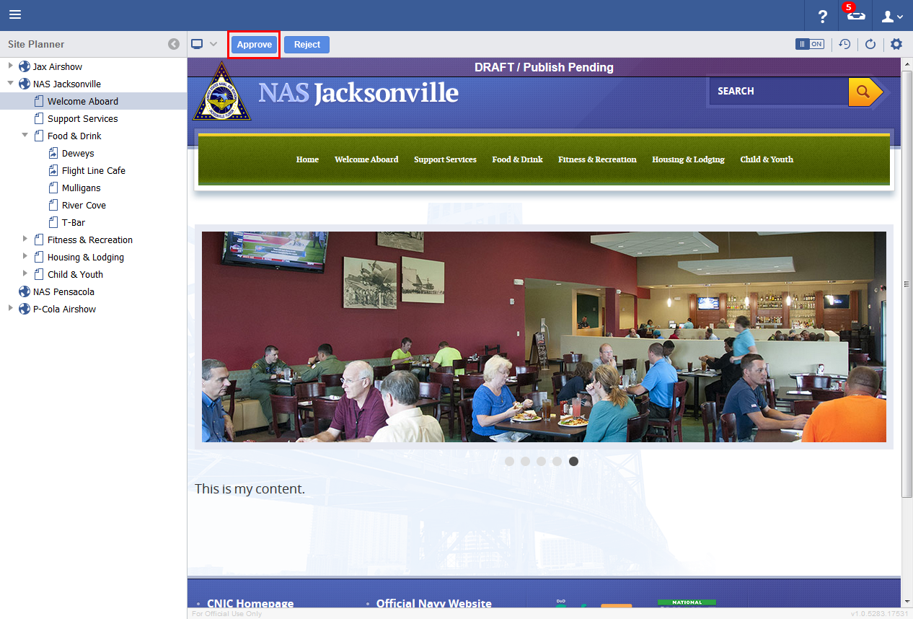
- Enter in an Approval message and click the Approve button.
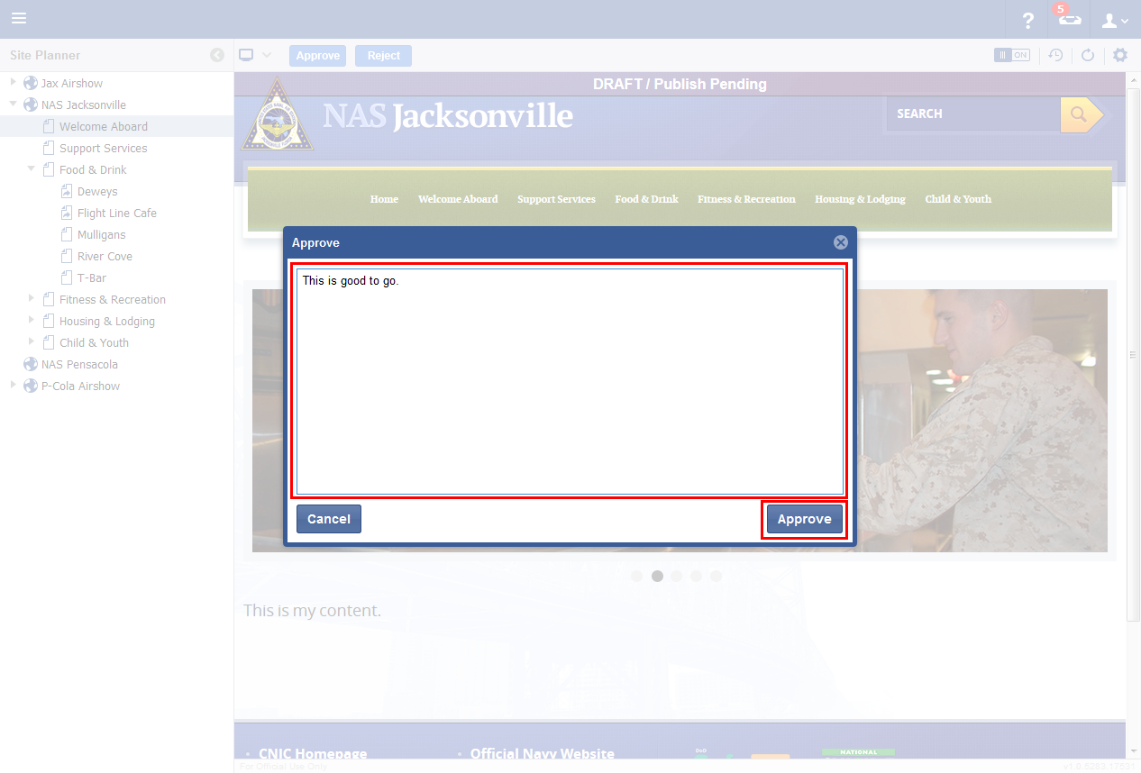
- Once approved, the updated page will show up on the frontend.

8
Creating Redirect Links

- In the Site Planner, select a page, and click on the Settings icon.
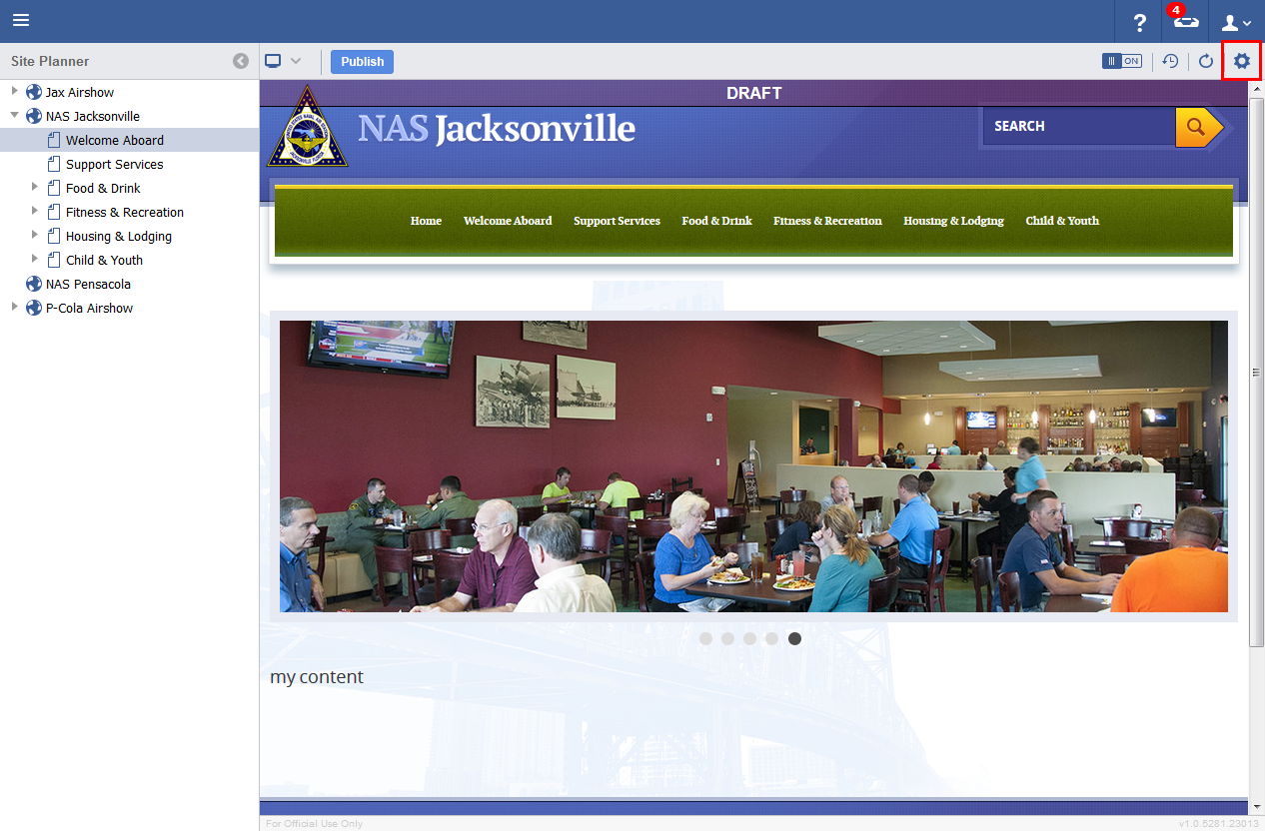
- Enter in a link to which this page will redirect to.
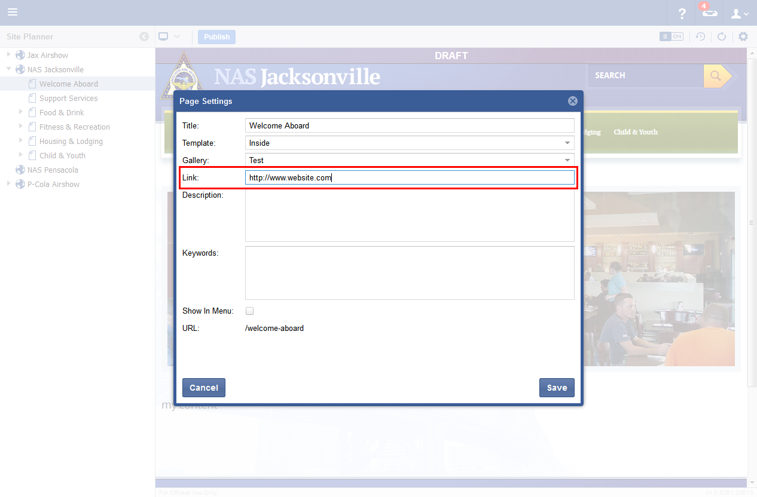
- Click Save.
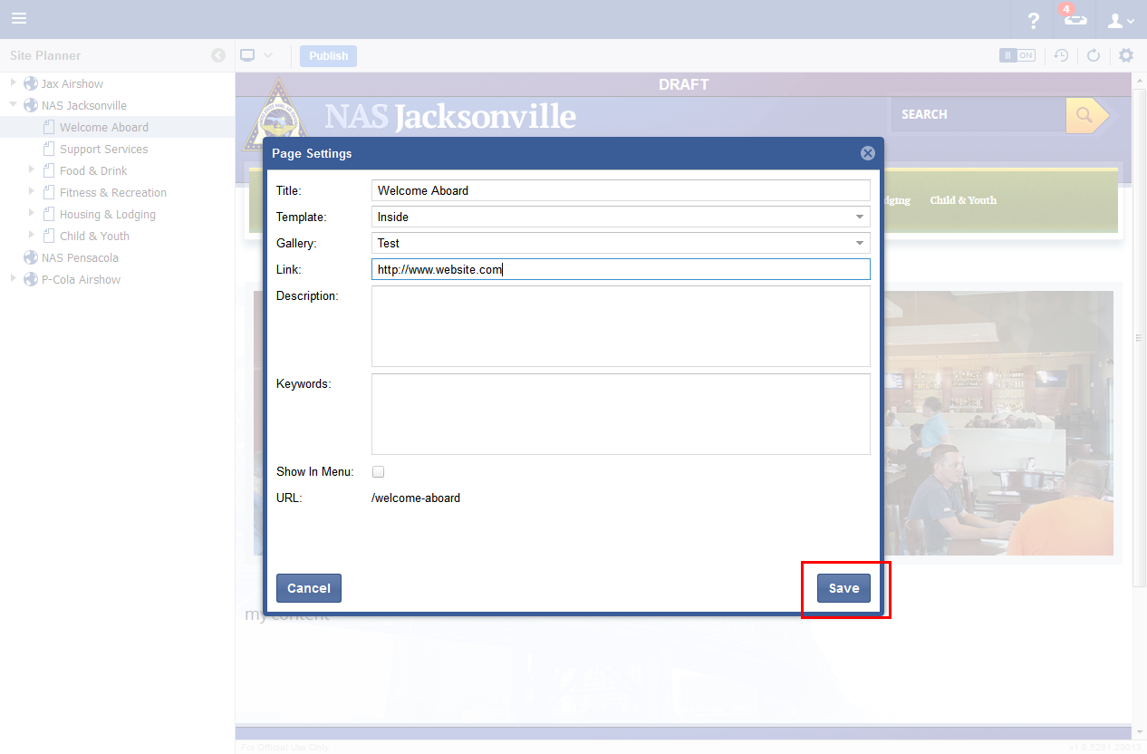
- The page icon changes to a Page Direct icon in the Left Menu and a message is displayed in the Content Area. To remove the Page Redirect, simply open the settings for the page and remove the link from the field and click save.
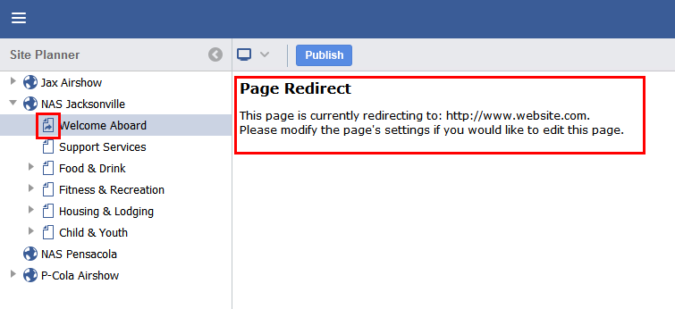

9
Components

Components are Widgets that allow for complex page elements to easily be added to a page. Double clicking on an item will insert the desired Component into the page at the current cursor position.
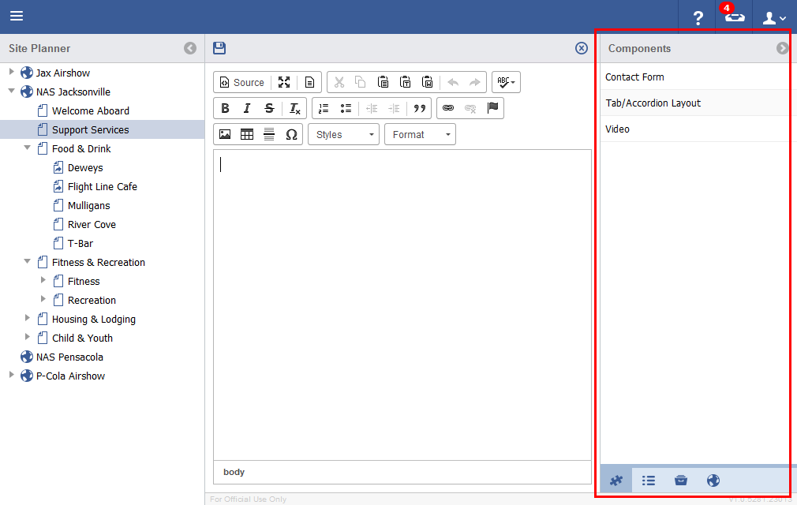

10
Smart lists
Smart Lists are components that enable the quick addition of lists made up of existing content. Items like News, Events, Announcements, FAQ, etc can be quickly added to a page.

- In the Site Planner, with a page selected, Click on the Edit Region Area.
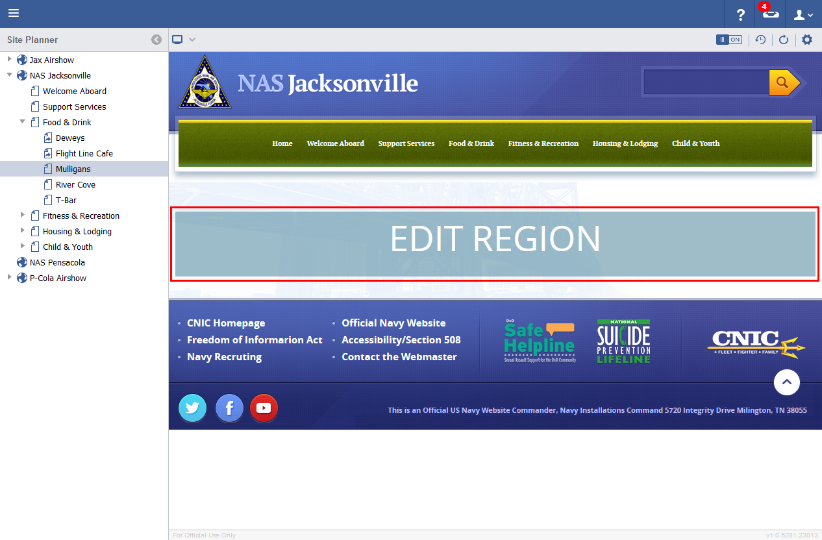
- Click on the Lists Tab in the bottom of the right Sidebar.
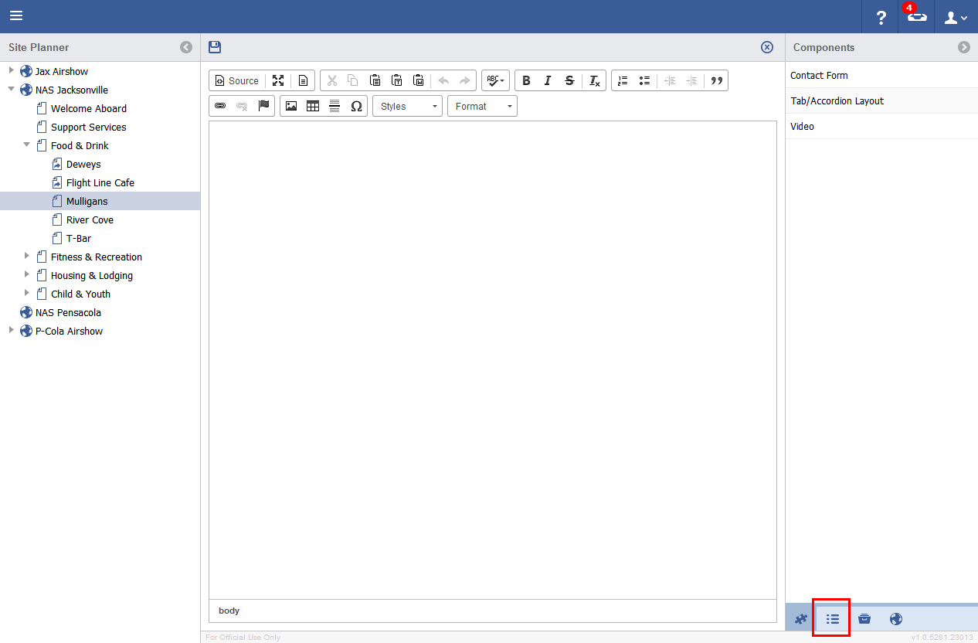
- Double Click on the News Item from the list, for example.
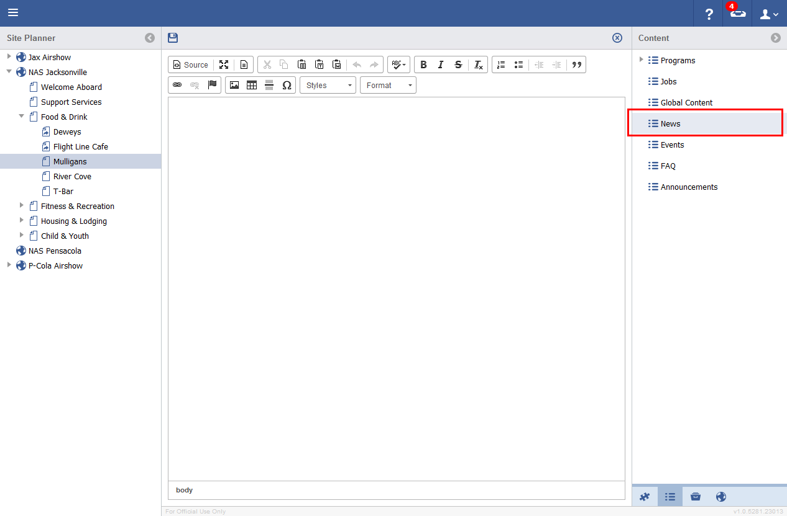
- Select a Style from the Style Dropdown.
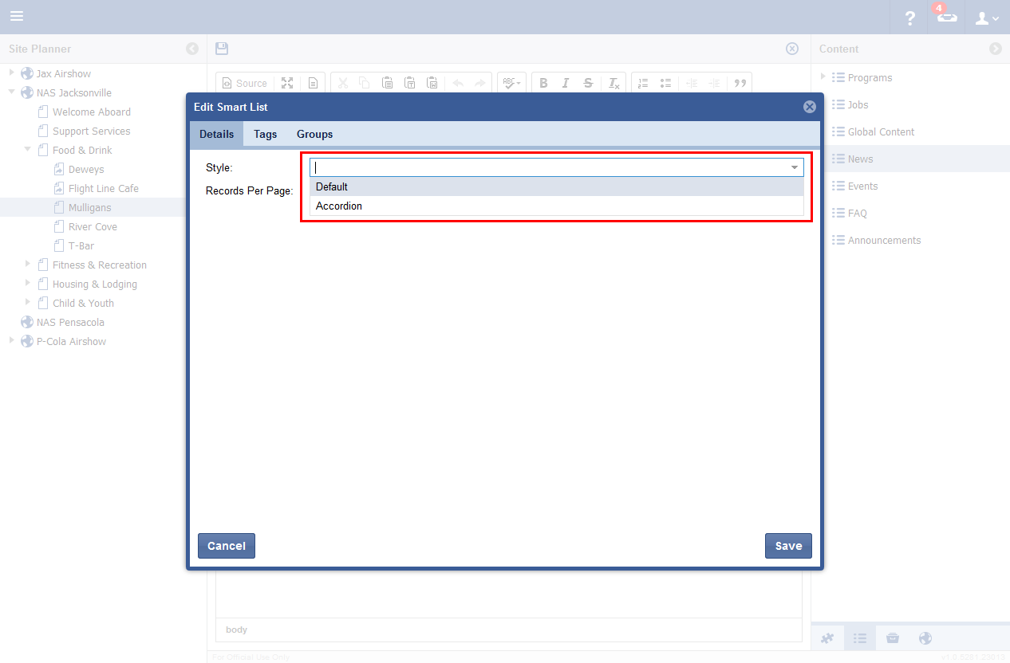
- Enter a value in the Records per Page field.
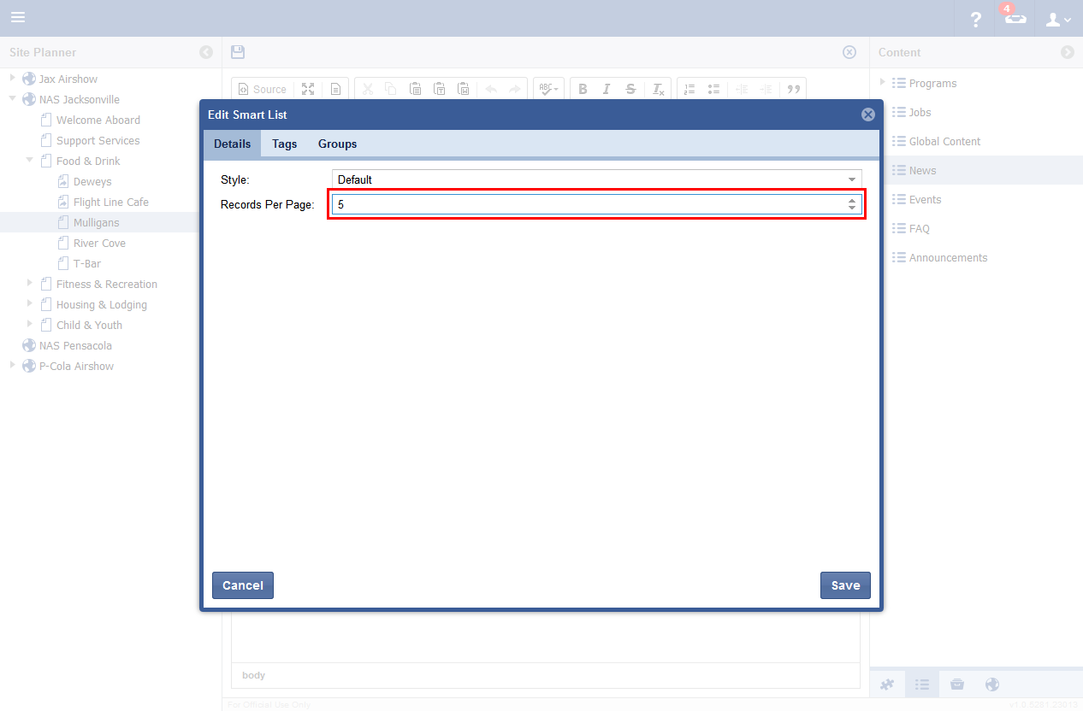
- In the Tags tab, select any relevant tags to be associated with the list, if any. Click on the arrow to add it to the right side of the list.
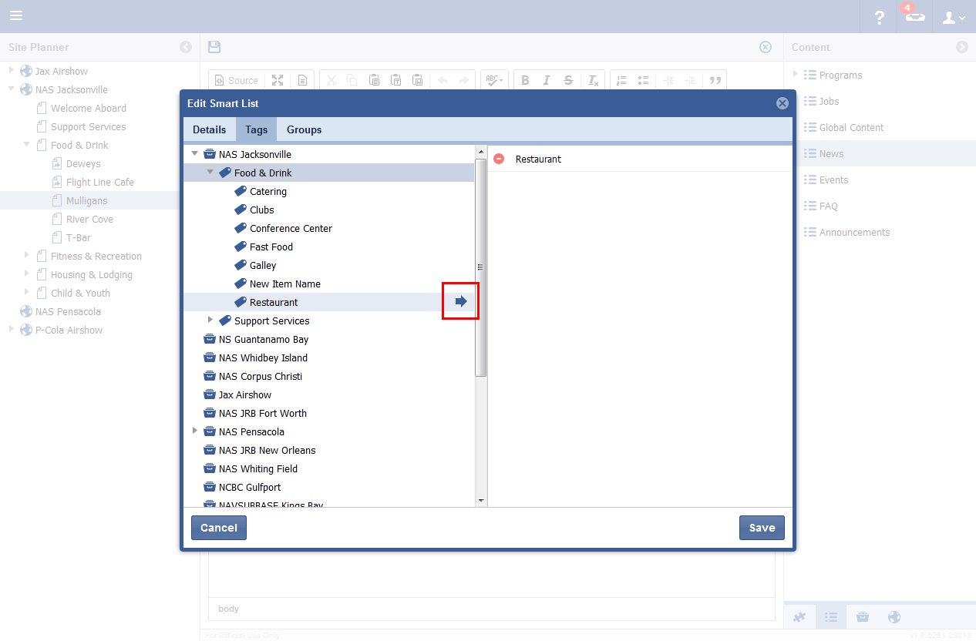
- In the Groups Tab, select Groups that will have access to view the list.
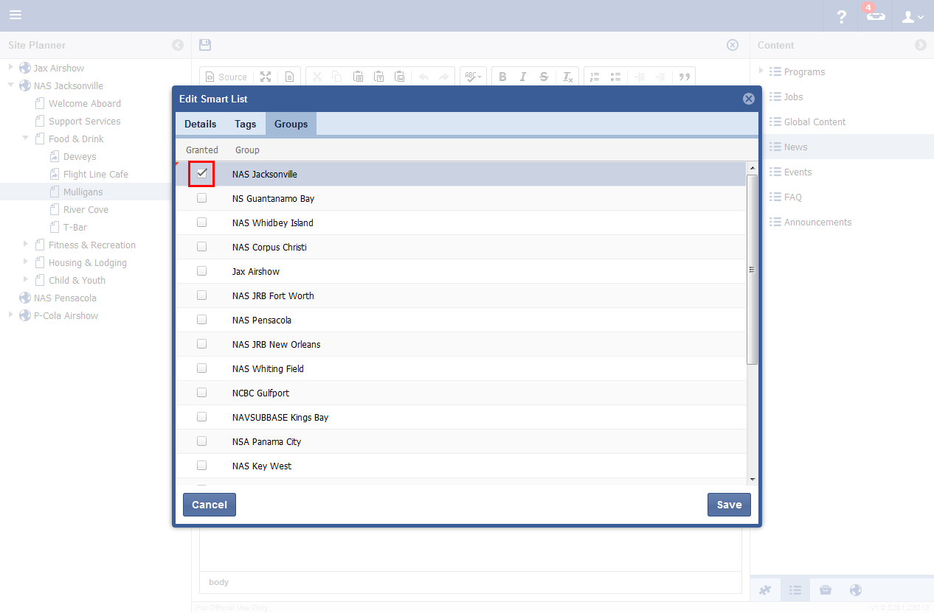
- Click Save.
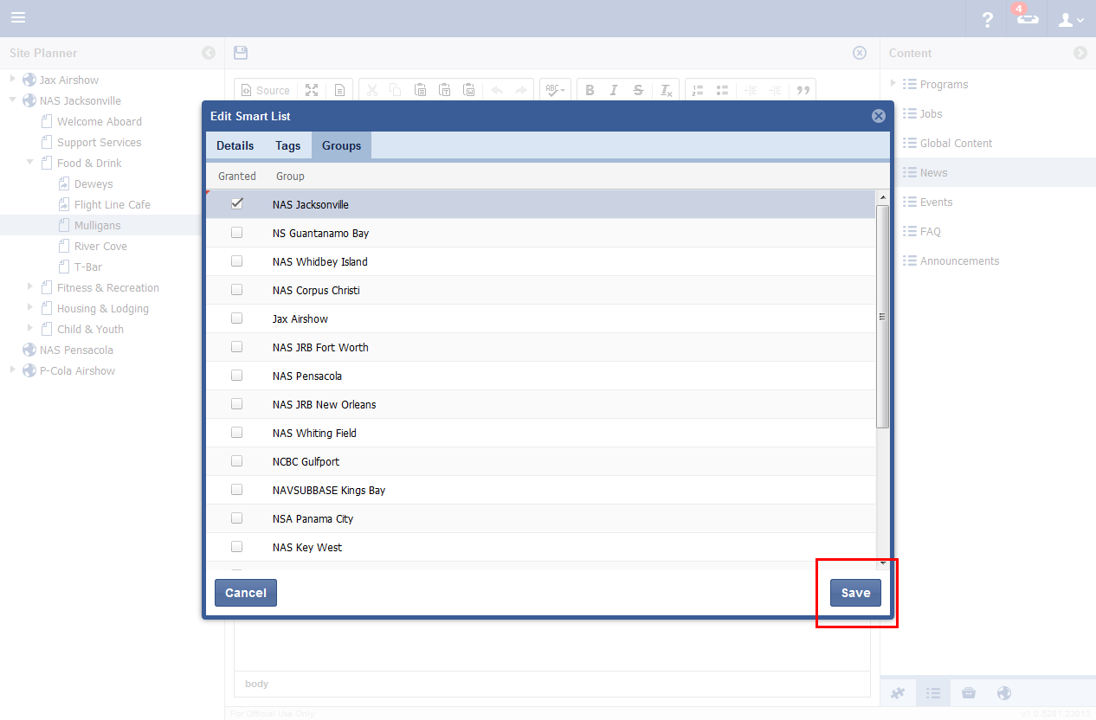
- A Smart List is created with options to add spaces above and below, as well as Edit and Delete buttons.
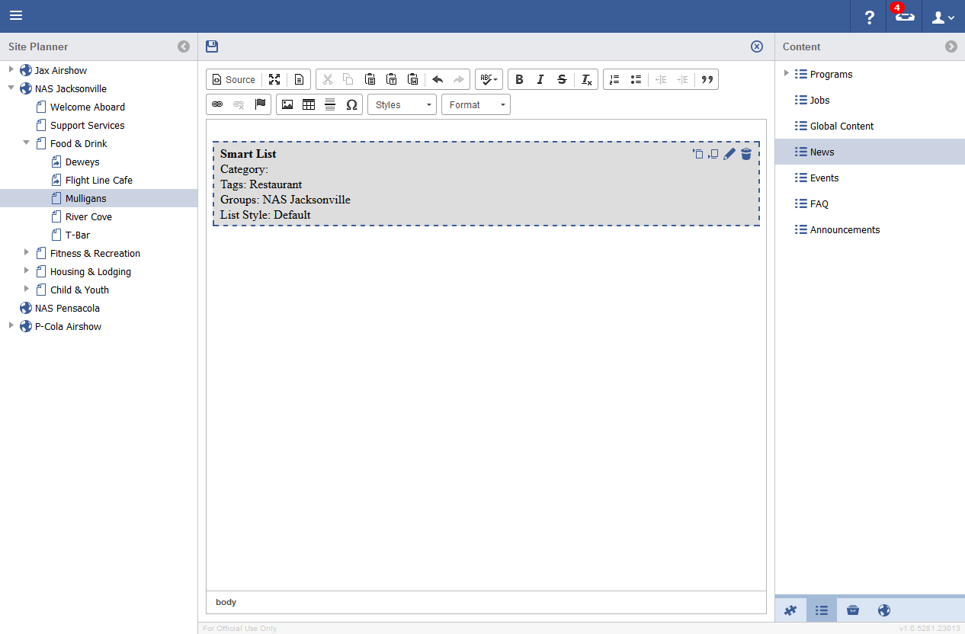

Smart List Buttons
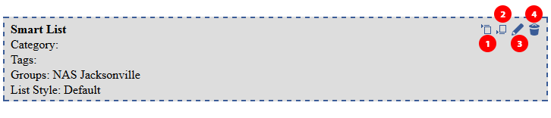
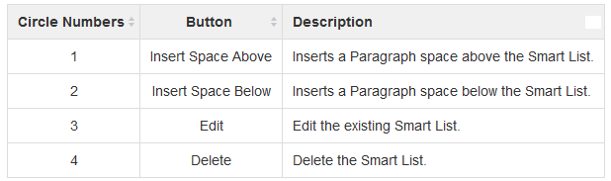

When a Smart List is saved to a page and previewed n the frontend, its styling will fit the look and feel of the site.

