Saving From Citrix

When saving from Citrix by default it is saving to your Citrix profile on the Server NOT your PC desktop. You will see an SAP folder or the file path is C:\Users\USER ID\Documents\SAP\SAP GUI\ as your clue. You will not be able to retrieve what you saved on your PC.
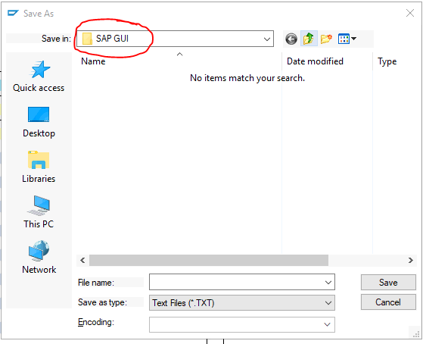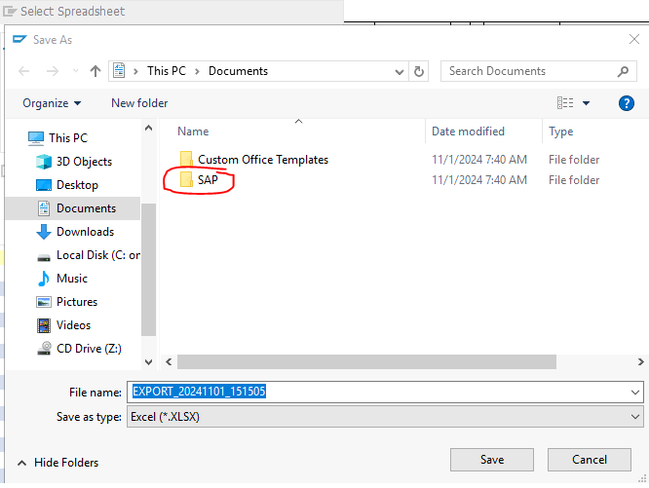

Click This PC
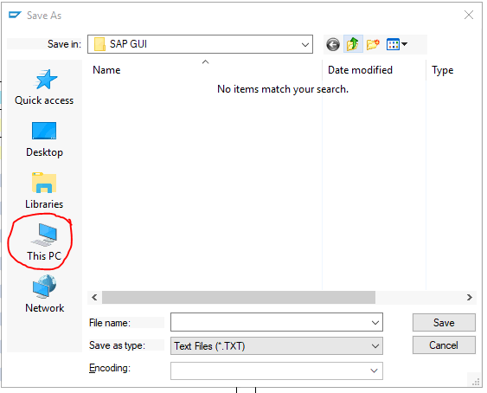

Scroll down until you see Local Disk (C: on xxxxxx). It will be your computer name. Double Click to open.
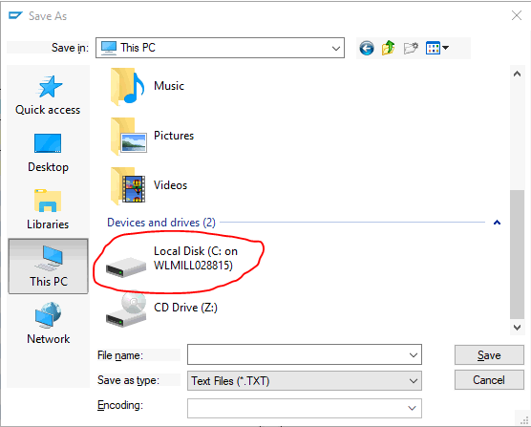

Scroll down until you see the Users folder.
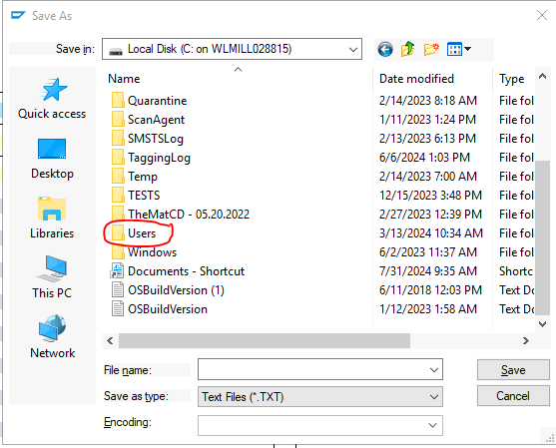

Locate your profile folder with your name on it. Double click to open, and now you are on your PC profile and will be able to locate and open the saved files.

