We have updated the 2026 Mil Promo ticket Rec Trac IDs to streamline the import process and eliminate potential confusion for sellers. Please see below Enouncement information:

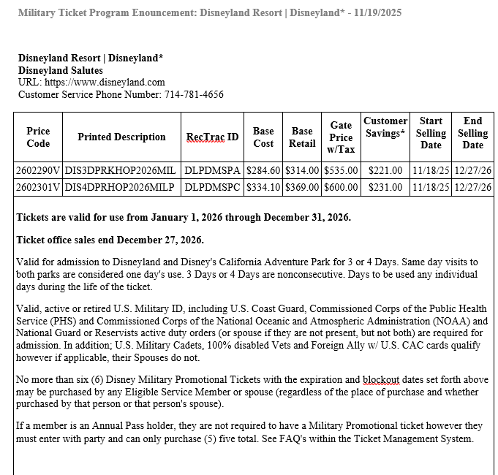

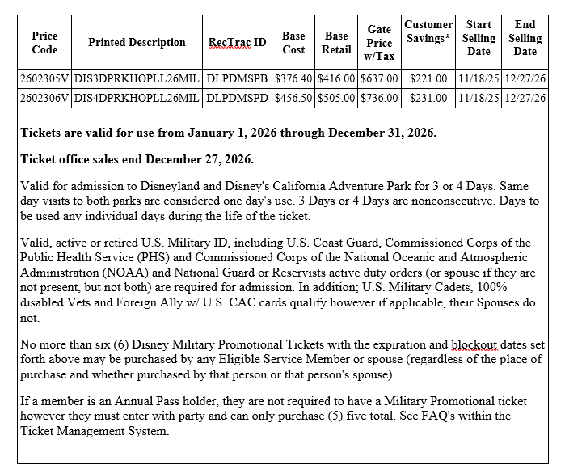

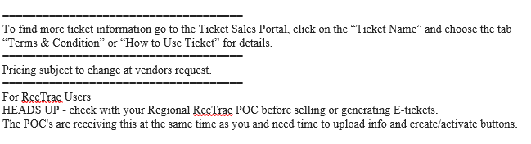

Bonnie Gray
Military Ticket Program Manager
Hours of Operation: Mon - Fri 7:30 a.m. - 4:00 p.m. CST
Closed Holiday & weekends.

