Saving From FFR Portal

Click Export to MS Excel.
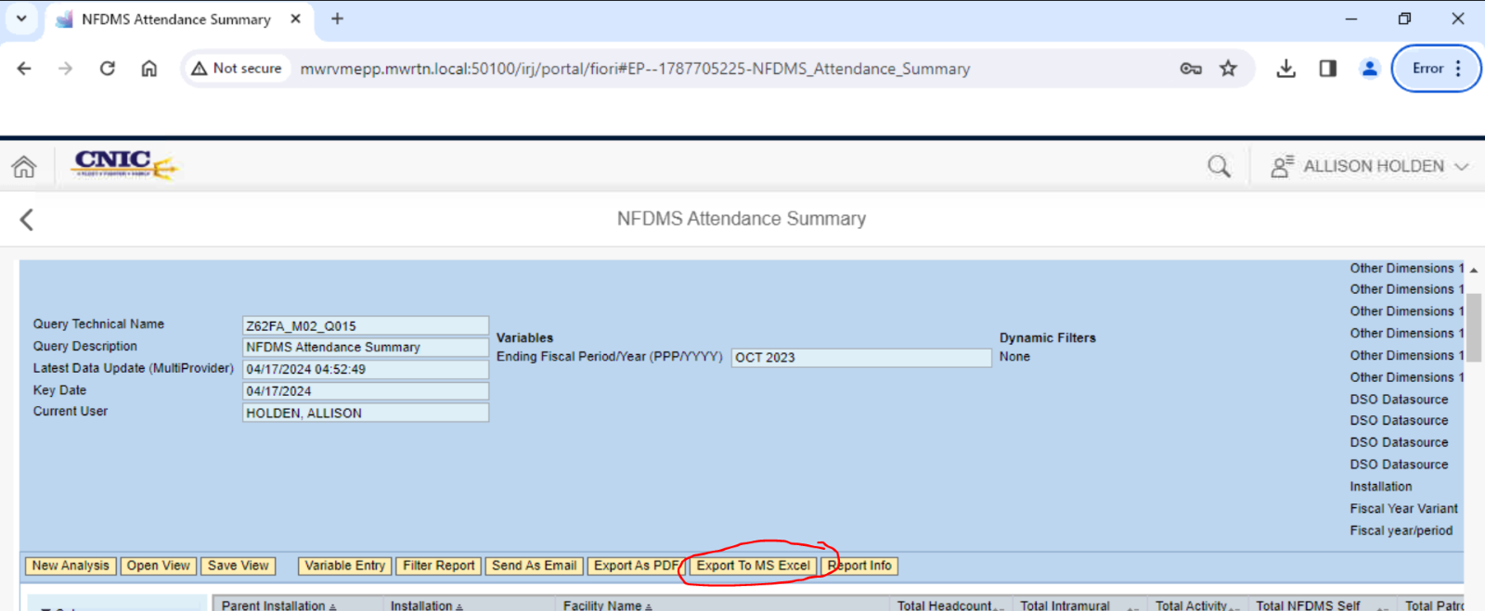
Click the arrow button
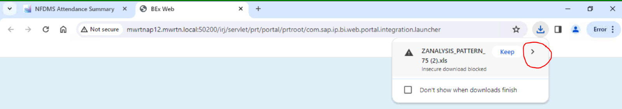

Click Download secure file button
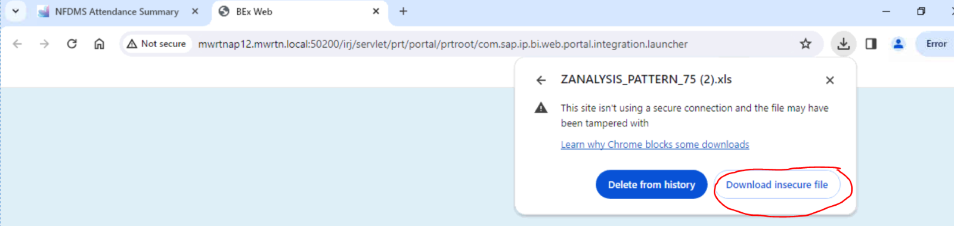

Click Show in Folder button
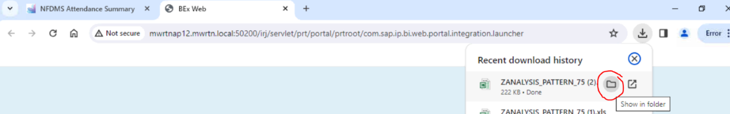

Right click on the report you just downloaded. Click on Open with…
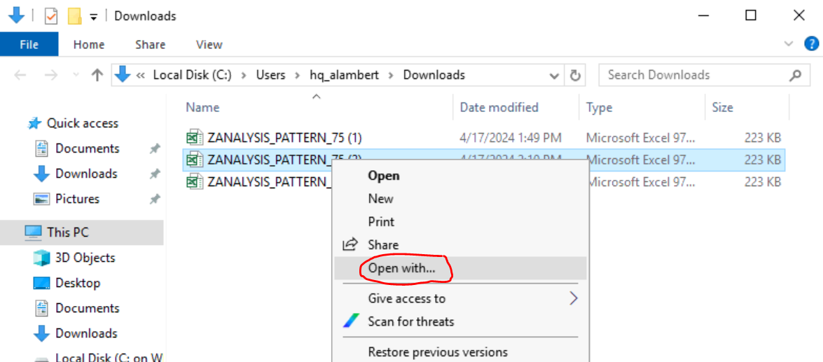

Make sure Excel 2016 is selected and check Always use this app to open .xls files. Click OK button.
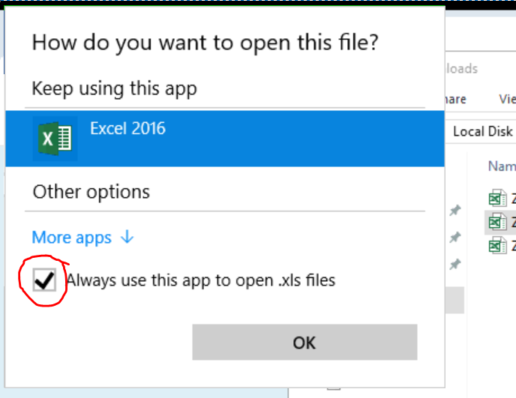

Excel should open and give you a prompt. Click YES button.
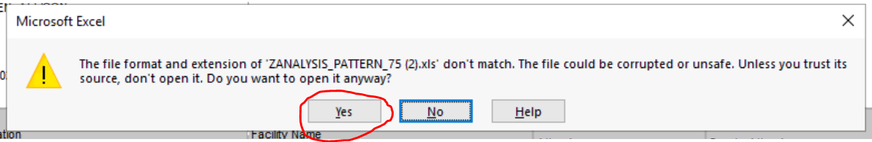

Try the Save As -> Browse -> This PC -> Local Disk C:
This may give you the option now. Since you are not on the web browser.

